REPORT ON THE CONDUCT OF THE LOCAL COUNCIL COMMITTEE ELECTION PROCESS
OF THE KATAMBWA DISTRICT YOUTH (CLC).

- INTRODUCTION AND CONTEXT:

On Saturday, August 15, 2026, the election of members of the Bureau of the Local Youth Council (CLC) of the Katambwa neighborhood in the Lac district of Kalemie, Tanganyika Province, took place. This activity is part of the revitalization of grassroots youth structures and aligns with the vision of promoting the emergence of a conscious, engaged, and active youth, as advocated by COJESKI-DRC.

The event benefited from the technical support of the Collective of Solidarity Youth Organizations of Congo-Kinshasa (COJESKI-DRC Coordination of Tanganyika) before during and after elections, thus realizing its firm commitment to propel young Congolese to consult with each other and to participate effectively in the decision-making bodies of their local entities.

- ACTIVITY OBJECTIVES:

  - General objective : To establish a representative, democratic and legitimate committee to lead the KATAMBWA Local Youth Council,

  - Specific objectives :

- To promote democratic expression among young people in the neighborhood,
- Strengthen youth citizen participation in local decision-making,
- To provide the division with a youth structure for advocacy, rights defense, and community development,
- Introducing young people to local leadership and grassroots solutions,

- CONDUCTING ELECTORAL OPERATIONS:

The election took place in a calm, transparent and inclusive atmosphere, following the steps below:

- Welcome and setup: Arrival of delegates from the various youth associations in the Katambwa division and local authorities,
- Establishment of the Elderly bureau: Facilitated by the technical team from COJESKI-DRC Coordination of Tanganyika to guarantee the neutrality of the process,
- Presentation of candidacies and campaign: Each candidate had a few minutes to present their action plan,
- Voting and counting: The vote was conducted by secret ballot, followed by a public count in the presence of all participants and observers,

- ELECTION RESULTS:

Following the vote count, the new office of the Local Youth Council (CLC) / Katambwa is composed as follows: President, Vice-President in charge of administration, Vice-President in charge of gender, families and children, Vice-President in charge of financial affairs, Secretary-Rapporteur, Deputy Secretary-Rapporteur, Head of Public Relations and Mobilization and Treasurer.

- RECOMMENDATIONS AND PERSPECTIVES:

Taking the opportunity to speak, the Katamwa Division Chief and the President of the Lake District Youth Association first thanked the COJESKI-DRC Tanganyika Coordination for its commitment to supporting the youth of Tanganyika. They then urged COJESKI-DRC to remain a close partner and to support these young people throughout their journey, not only with technical assistance but also by directly involving them in the implementation of their various projects. Following this, the two authorities (Katambwa Division Chief and the President of the Lake District Youth Association) made the following statement to COJESKI-DRC:
- Organize a capacity-building session for newly elected officials on leadership and association governance.
- To support the new committee in drafting its priority action plan for the Katambwa district.
- Advocate with local authorities for the systematic involvement of this committee in neighborhood development meetings.

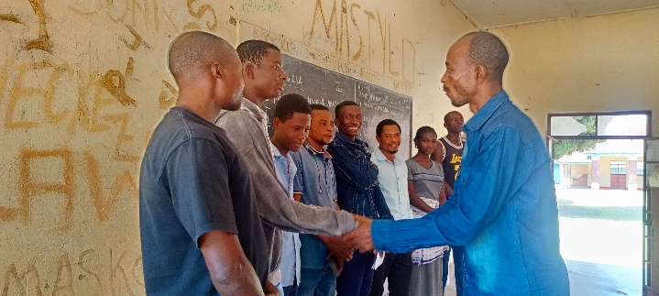
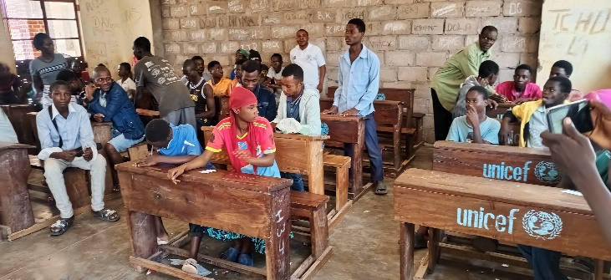
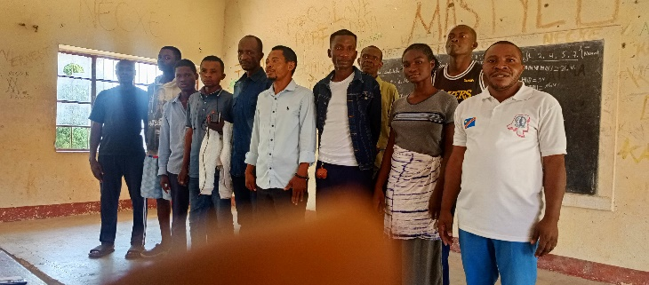
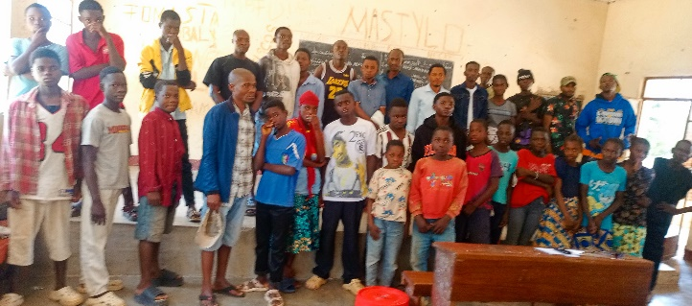
In conclusion: The election of the Katambwa CLC committee marks a key step for the political and social participation of young people at the local level. Thanks to the technical support of COJESKI-DRC Tanganyika Coordination, the Division now has a legitimate structure capable of representing the voice of youth to decision-making bodies.

Done in Kalemie, on August 15, 2026.

For the COJESKI-DRC Coordination of Tanganyika

Germain MIRHONYI.

