Global Refugee Leaders Forum (GRLF)
Annual Report 2024


Contact:
No 172 Nzangi Butondo Road, Kituku One Avenue, Kyeshero Goma, North Kivu, the Democratic Republic of Congo,
Tel: +243853191163, Email: refugeeleadersforum@gmail.com
Website: https://www.globalrefugeeleaders.org/
Background information
About GRLF…………………………….
About the Report………………………………..
Legal framework…………………………………
Social situation………………………………..
Political situation…………………………………
Introduction about the situation of Refugee Leaders
About refugee leaders in the Great Lakes Region ……
Humanitarian Actors…………………………………
Human Rights Defender Organizations………………
Host communities……………………………………
Government institutions……………………….
Challenges faced by refugee Leaders
Physical security………………………………………..
Freedom of movement…………………………………..
Deportation……………………………………………….
Assassinations…………………………………………..
Forced Repatriation……………………………………..
Arbitrary arrests…………………………………………..
COJESKI main activities in 2024
Message from the Executive Director Mr. Kulihoshi Musikami Pecos
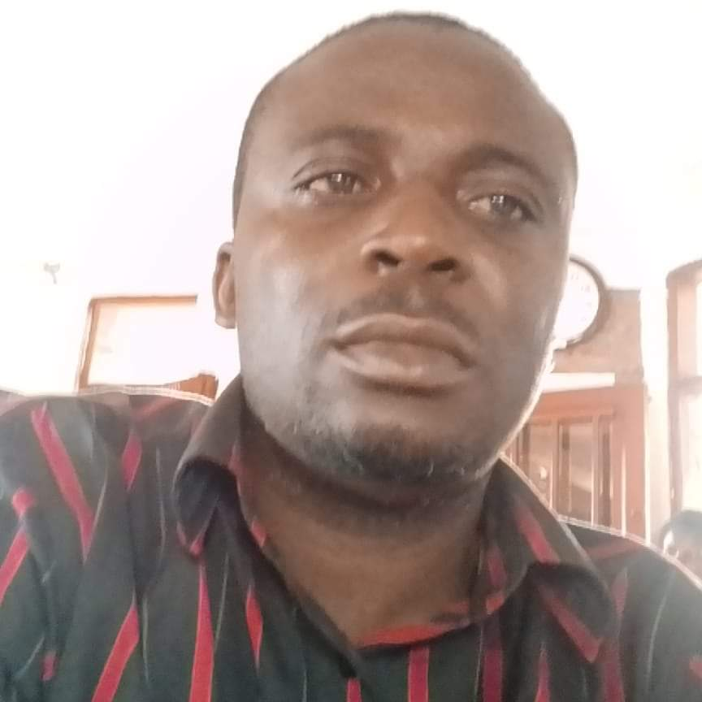
“Being a refugee is not a choice but deciding to help refugees is a choice which we can all make”
I get this opportunity to share with you all the best and worst moments in our struggle for the protection of refugee leaders in the in Africa in general and in the Democratic Republic of Congo in particular. It may be also a challenge to really measure the progress along this year 2024, but I’m happy that we have been in contact with some refugee leaders almost in all countries in the Great Lakes Region and in the East Africa Community.
It is a pleasure for us to observe that our existence continues to give hope to refugee leaders who have been informed about us, and now are yearning that our activities may reach to them as soon as possible, so it is important for us to know that our mere existence brings hope to some people. These refugee leaders carry more than 70% of the whole refugee workload on their shoulders, and as they are helping others, generally no one helps them also to continue moving forward.
While compiling this report my eyes are turned towards unknown and invisible refugee leaders in their communities who are playing a great in order to save the lives of many refugees and yet no one recognizes them, sometimes they put aside their own problems as refugees and focuses on the problems of others, sometimes they are themselves victims of all forms of abuses because of helping other refugees, some are wondering when will they be recognized and supported.
Lastly, I am fully aware about the lack of interest in refugee affairs especially in Africa where refugees do not present a political and economic opportunity in order to attract the attention of politicians. Over years refugees have been politically manipulated, since 1980 refugees in the Great Lakes Region and in the East Africa Community became political and military actors, many were recruited in military activities and have caused wars which have displaced millions of others refugees. The different wars in the Democratic Republic of Congo have been started by refugees, this should be our focus on how best we can protect refugees and demilitarize all refugees in the regions.
Please enjoy our annual report 2024.
About the Global Refugee Leaders Forum (GRLF)
Background information
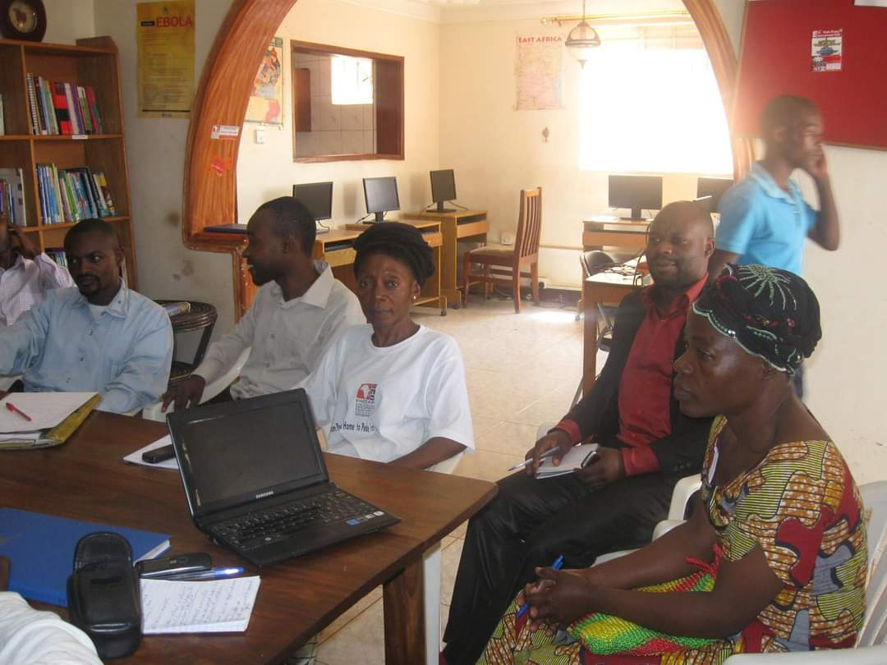
“Some refugee leaders during a meeting at PADEAP in Kampala Uganda. Some are still in Uganda, some are still active, and some left Uganda and others are abusing the same refugees they are fighting for”
The Global Refugee Leaders Forum (GRLF) is Project of the Collective of Youth Organizations for Solidarity in the Democratic Republic Congo. The GRLF started as a refugee led organization in Uganda focusing on empowering and advocating for a conducive environment in which can operate refugee leaders in order to improve the situation of the refugee population. Later on the initiators decided to return back to the Democratic Republic of Congo, where the project is now implemented. The GRLF is focusing on both individual refugee leaders and groups of refugees through capacity building of refugee leaders in their various thematic and at the same time institutional capacity building in order to enable them to have strong structures in place which can push for change.
Why did we start this initiative?
While in Uganda, we observe the creation of various refugee groups, associations and organizations with different activities which benefited refugees, this was a great move and became an alternative to address the gaps that existed, at the same time some people offered services to refugees as individuals in their communities where they lived but not much attention was put on those individual refugees who support others, on contrary many were threatened, blacklisted and blackmailed because of their zeal to help refugees in need.
Despite the desire to start a refugee initiative, many did not last for long because those who started it were themselves refugees, did not have experience, did not have support and were lacking financial means in order to move forward, at the same time the question of the protection of key influential refugees who may have problems came up, and lastly the issue of those who help refugees despite being single individuals still they remain key in their various refugee communities.
Observation was made that generally refugee who left Uganda for resettlement in Developed main in Europe, USA, Canada and Australia among others, could not get involved in affairs of refugees who are still in Uganda in terms of advocacy, exploring existing opportunities and social support to initiatives they started. Generally initiatives started by refugees in Uganda did not continue once the vision bearer was resettlement to development countries, and this was a concern, many faced serious unhealthy competitions and others where politically influenced by the refugee regime in order to cause their collapse.
Lastly we observe that the challenges we faced in Uganda were similar to what other refugee leaders were also facing in their different countries, and generally refugee leaders lacked coordination in order to speak up on issues that affect them.
It was on this background that we decided to create the Global Refugee Leaders Forum which claim is to address all these challenges refugee leaders are facing at the individual level. We focus on the person first then that very person can also improve and focus on the group and on the community.
About this Annual Report 2024
This report was made in a highly deteriorating working environment for many refugee leaders in the great lakes region and in East African Community. Goma in DRC where we are based is highly affected by urban insecurity, and the current war of M23/RDF targeting primarily refugees, the political deal between DRC and Rwanda government on issues about refugees. The negative perception of Rwanda about refugees by calling them negative forces members of FDLR has reduced so much efforts towards their protection. In Rwanda many refugee leaders have been involved in political activities aiming at war against DRC and they have been the only ones allowed to speak up, all others live in fear and even could not feel comfortable to engage with us, in Burundi refugees are caught up in a situation of control in which they are now allowed to view a different opinion from the Government, in Uganda all vocal refugee leaders have been forced by the security services and the refugee management system to leave the country and different efforts have been put in place to discourage refugee advocacy activities, in Kenya despite of having opportunities to speak up, many are still in fear, in Tanzania refugee leaders are highly limited in terms of activities while in Zambia many could not feel free to engage on critical issues.
Since Covid19 many refugee leaders became financially too weak because all their income generating activities collapsed, they started again life from zero and they are still struggling up to now in a very hostile environment where they are excluded from accessing relief aid because of their engagement towards community affairs.
Refugee leaders remain highly fragmented in small groups and sometimes working individually and have not yet managed to have opportunities which bring them together.
Legal framework
This report is based on the Geneva Refugee Convention of 1951, and the United Nations Declaration on the situation of Human Rights Defenders of 1998. It is also important to note that each country has in place a refugee policy and institutions that are in charge of refugees which all are drawn from the Universal Declaration of Human Rights.
Generally all countries have some forms of enabling policies which could have supported the work of refugee leaders at all levels.
Social situation of refugee human rights defenders
Refugee Leaders in various countries are isolated to themselves, and have no opportunities to come together and exchange, there are rare conferences and events in which they are even invited in order to know each other and learn from each other. In DRC, Burundi, Rwanda, Tanzania, Zambia and Kenya there were no events at all that could bring together refugee leaders at national level, some sporadic activities were organized at local levels and only some few could manage to attend. In Uganda only one event brought together some refugee leaders especially those based in Kampala who were invited for the IGAD Refugee Summit.
Refugee leaders are in different groups, some are created by the refugee regime (Government and UNHCR) in order to serve their agenda, others are created by themselves because of the need in the community and others are just fund themselves in the refugee leadership. Some are independent while others highly depend on the refugee regime and because of this diversity they hold a variety of interest and this is the basis of their divisions.
Namegabe a refugee leader in Uganda indicated “Actually, I was just at home and then during the refugee elections they called me at OPM Offices and told me to stand, they gave me money and I won the elections. As long as I do what they tell me to do, there is no problem that is why sometimes I cannot mixt up with other leaders because now we have different interests”.
International Days Celebrations
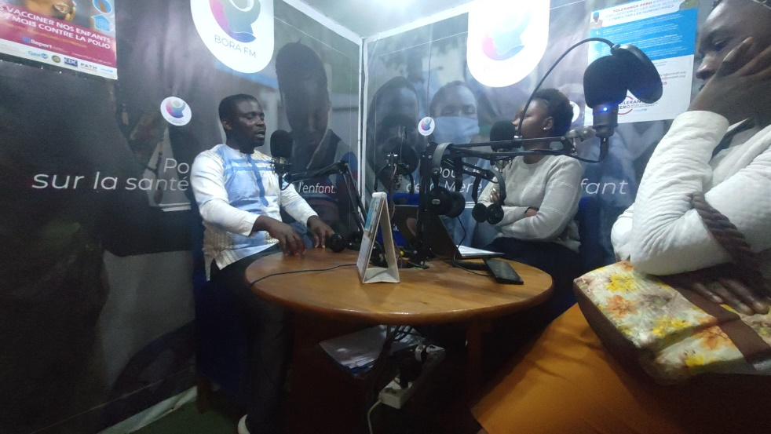
“Media engagement in Goma, DRC on the Commemoration of the International Day of Relief Aid”.
Despite the existence of many international days which should be commemorated and bring together all refugee leaders at national and local levels, only international organizations organized these events and in the process invited few refugee leaders basing on how best these refugee leaders are royal to them. Even on the world refugee day, refugee leaders could not manage to plan and execute activities which can put them together.
Recommendations
The need to organize commemoration of big international recognized days at each level, community, local, national and regional in which refugee leaders should be invited and even as organizers,
To organize field visits of refugee leaders to other countries and other places where they have not reached, in order to learn lessons from others and build contacts,
To organize various capacity training sessions and events which regularly bring together refugee leaders,
Economic challenges
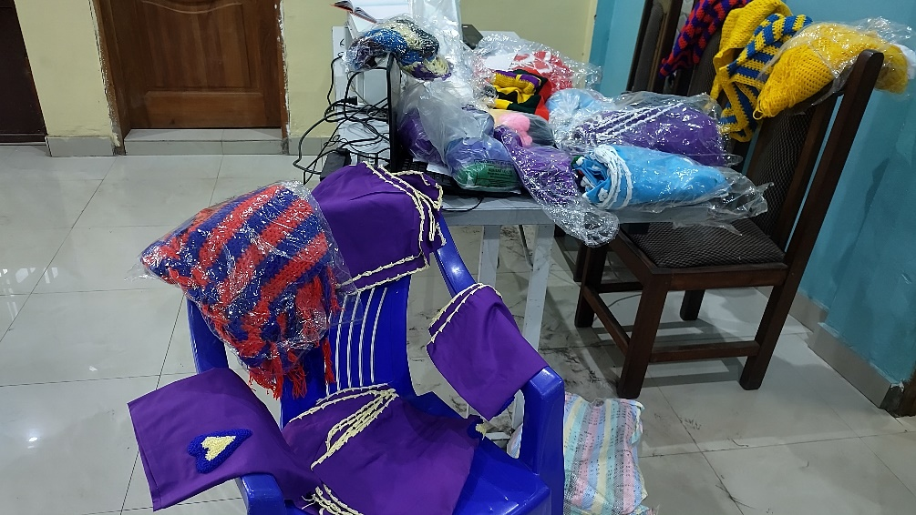
“Income Generating Activity of refugee leaders in Goma, the Democratic Republic of Congo”
Many Refugee Leaders in all various countries are struggling economically, some lost all what they had during COVID19 and nothing has been done in order to help them to recover despite their resilience, others where even economically weak before COVID19 and this situation they do have a stable income generating activity that can address their basic needs. In many cases refugee leaders were not able to pay their house rent, get food for their families, afford education for their children, and basic medical treatment, not able to afford transport in on order to follow up come refugee issues. The failure even to afford communication through social media has been among them challenges because they are living in destitution.
Recommendation
To mobilize funders and different partners to come in and help refugee leaders to overcome poverty through income generating activities and entrepreneurship, including projects that may be consumed in their areas,
Skill development: To promote skills among refugee leaders so that they use their skills in order to earn money and develop their talents, this should be through a well- tailored project,
Education: The promotion of education opportunities focusing on refugee leaders is one among the approaches we should capitalize, especially advocating for the relocation of a certain scholarship to refugee leaders,
Create events at various levels in which refugee leaders can participate in and ensure that such events are fully funded,
Refugee Leaders Rewards
While refugee leaders who work closely to the refugee regime have ways of being awards in case they have been viewed as loyal, those who have opted to be more independent are totally left out and do not benefit anything, they are always left out and cannot benefit from any opportunities.
This year has just ended and no refugee leader has been rewarded as a sign of motivation and encouragement, no refugee led initiative received reward for the work that is being done and no refugee leader was given a particular attention as an appreciation of what he/she is doing.
Recommendation
There is a need to organize awards for exemplary refugee leaders who have distinguished themselves in what they are doing. These awards can be either at community, local, national and regional level and why not at international level,
Awards should be extended to all those who have been exceptional in what they have been doing, and this should focus on each category of leaders,
Funding opportunities
Since COVI19 funding opportunities towards refugee initiatives reduced and become almost inexistence during this year 2024. Very few refugee led organizations accessed funding for their activities. Those which are funded are either connected to the refugee regime or just implemented a project which belongs to the refugee regime.
Recommendation
There is a need to advocate for flexible funding opportunities which can benefit refugee leaders and their initiatives so that they can progress in what they are doing,
Donors should provide funding focusing primarily to independent refugee leaders in order to progress with their activities,
Political situation
Refugee Leaders are operating in a very hostile political environment especially those who in Eastern African Community and the Great Lakes Region where in one side refugees are considered as booming businesses and tools to use in order to convince donors to bring money, the more you have refugees in your country the more money you get from the donors and the more you divert the money to other things and ensure that refugees do not complain, on the other hand refugees are used into military activities generally refugee camps are mere military reserves where they are recruited for military operations in the Democratic Republic of Congo. The notion of refugee rights has to exist in countries where human rights for the citizens are not respected and where donors always compromise with leaders of the countries for political interests and positioning in the name of supporting refugees.

Introduction about the situation of Refugee Leaders
About refugees in the Great Lakes Region:
It is not clear at what extend refugee leaders are involved in helping other refuges to live better because no research has been made, it is not also clear to know what the situation of refugees would have been if refugee leaders were not there. What is evident is that their role and presence among others are vital and cannot be replaced. In the Democratic Republic of Congo almost 95% of services to refugees are depending on what refugee leaders can offer basing on existing opportunities, this is because humanitarian actors withdrawn from helping refugees.
The work of refugee leaders in this situation is huge from looking for information and sharing to communities, representing the communities and building up the links, defending communities, and sharing with them opportunities that may be capital to members of the communities.
Humanitarian Actors…………………………………
Generally in all countries both in Easter African Countries and in the Great Lakes Region refugee leaders carry on their shoulders the heavy burden of refugee plight on top of theirs, so they carry double burden but unfortunately they are not supported by humanitarian actors. Leaving refugee leaders to suffer alone is sometimes of design in order to discourage those who would explore local solutions to the problems of refugees. This humanitarian agent shared with us in Goma/DRC “this is confidential and do not mention my name, but as humanitarian actors we always want where there are problems, disasters and people are dying so that we can easily mobilize the funds, now these refugee leaders are trying to block this to happen, how do you expect us to help when they are killing our deal on which we should survive also”.
And this process as we engaged refugee leaders in order to better understand this field one among refugee leaders in the Democratic Republic of Congo said “look here, you cannot imagine my role in the community, I do a lot, but I have been blacklisted by UNHCR, there is nothing I can get from UNHCR because I’m critical to what they are doing to refugees”.
Human Rights Defender Organizations………
A progress has been made, and refugees are included as part of the targeted population by some human rights organizations, on top of that Human Rights Defenders have also included those who defend refugees in their activities and interventions. But that has not impacted something on the ground in the lives of vocal refugee leaders, during this year 2024 none among refugee human rights defenders at risk was supported. We are getting the same narrative, either it is a silence or it is the same rhetoric of advising refugee human rights defenders to go to UNHCR.
Recommendations
Human Rights Organizations should put in place a special programme targeting refugee leaders,
Refugee Leaders should be well trained in the field of human rights,
Human Rights Defenders should empower refugee leaders on security threats management,
Host communities………………………………
Refugee Leaders are exactly the link between refugees and the host communities, many refugee leaders have generally survived through the support and solidarity they do receive from the host communities. This support is often in terms of economic opportunities, social integration and general welfare of refugee leaders. In the Democratic Republic of Congo, refugee leaders we visited shared their experiences how they are being supported by the host communities, this one told us “I’m a farmer but this land I’m using a Congolese friend gave it to me freely, and it is where I also put my house”. Moses this is not his true name “this house I’m living in is for a Congolese man who gave it to me for a while, and when my fellow refugees come here they think I’m rich because I’m living here”.
DRC Government institutions………………………
The Democratic Republic of Congo has a very weak state authority in almost everywhere, the government institution working on refugees highly depends of UNHCR and because of that it may not do much. The institution known as the Congolese National Commission for Refugees (CNR) is not only too weak to advance the protection of refugees but it is also perceived as being influenced by Rwanda.
Recommendations
To reform the CNR through new policies and human resource that can fully engage on the protection of refugees,
To support CNR financially and make it more independent from UNHCR and advocate for a budget allocation,
To empower CNR in refugee issues including refugee protection, refugee rights and effective refugee management,
To help CNR to organize credible refugee elections of refugee welfare committees,

Challenges faced by refugees
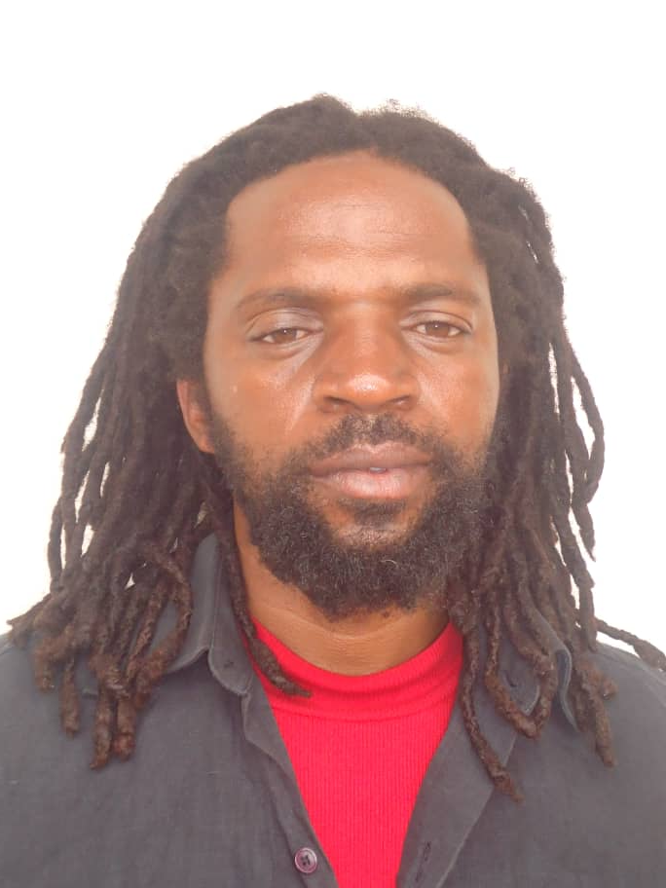
Musirikale Rasta Marcel, one among the active and vocal refugee leaders in prison in Kampala currently.
Physical security…………………………………
The physical security of Refugee Leaders became worse during this year 2022 and countries like Rwanda and Uganda played a frontline role in abuses and threats against refugee leaders. As per now all the three (3) active and critical refugee human rights defenders and community leaders are living in fear in Uganda among them two (2) are hiding and one (1) is in prison in Uganda. While in Rwanda refugee leaders feared to speak because they were being monitored by people they suspect to be associated with security services.
Freedom of movement………………………
Uganda has particular in the region to grant Refugee Conventional Document, however also these documents were limited to only those who are viewed as cooperative with the refugee regime, up to now critical refugee leaders in Uganda are not granted the travel document. This year very few refugee leaders from Uganda were granted a visa for a meeting in Europe much as opportunities for refugees to travel were very few.
The situation is extremely worse in the Democratic Republic of Congo where almost no refugee has a travel document, even those who are friends to the refugee regime do not have and this has blocked refugees in DRC to appear in international events.
This year also had very few opportunities for refugees in order to travel and at the same even for the few opportunities the attention was not put on refugee leaders in the Great Lakes Region.
Recommendations
We call upon countries to remove all restrictions for refugees to travel such as denying them a visa, denying them a travel document and not supporting them to move,
We call upon various actors who organize events and issues about refugees to prioritize the participation of refugee leaders in the Great Lakes Region,
We call upon DRC, Rwanda and Burundi Governments to easily and quickly grant travel documents to refugees especially refugee leaders,
Forced repatriation……………………………………
The Government of the Democratic Republic of Congo and the United Nations High Commissioner for Refugees (UNHCR) continued their practice of forced repatriation of refugees back to Rwanda among them refugees leaders, we also observed repatriation of refugee leaders from Uganda back to DRC when they realized that their security deteriorated in Uganda, and as at the moment some refugee leaders living in difficult situation are looking for ways to leave Uganda towards either Kenya or DRC.
Recommendations
We call upon UNHCR and DRC Government to put to end forced repatriation activities especially focusing on Rwandan refugees among them refugee leaders,
We call upon Uganda to create a better environment in which refugee leaders can feel safe to work and advocate on refugee issues,
We call upon all countries in the region to put a particular attention on the situation of Refugee Leaders in their respective countries,
Denial of Relief Aid…………………………………..
Generally all refugee leaders do not access to relief aid in all countries and this is viewed as a strategy to weaken them and push them to stop what they are doing. The work on refugee leaders is wrongly interpreted as a competition towards international humanitarian agencies and may threaten what humanitarian actors are doing, thus the need to deny them support.
Recommendation
We call upon relief aid agencies to lift the ban on granting humanitarian assistance to refugee leaders,
Threats and intimidations…………………………..
Refugee leaders in Uganda are generally among those facing all forms of threats and intimidations caused by state actors, as those in Rwanda cannot just say anything because of the oppressive environment.
Recommendation
We call upon Uganda and Rwanda to create a better environment of refugee leaders to work on, and end all threats and intimidations against them at all levels,

Global Refugee Leaders Forum Activities
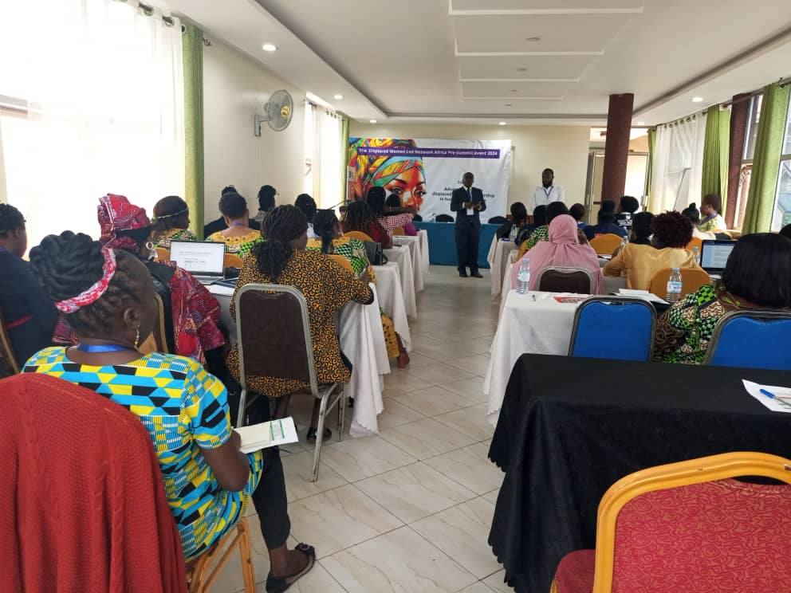
Sharing information on refugee issues during a meeting in Kampala Uganda targeting refugee leaders and other in terms of capacity building
Identification of refugee leaders………………..
We continued with the identification of key refugee leaders in each country and this year we managed to identify key refugee leaders in the following countries and areas in those countries:
The Democratic Republic of Congo: North Kivu, South Kivu, Tanganyika, Katanga, Lomami, Kinshasa, Ubangi, Kisangani, and Ituri.
Uganda: Kampala, Kyaka II, Kyangwali, Nakivale, Bidi Bidi, Rwamwanja, Rhino,
Kenya: Nairobi, Kakuma, Dabab,
Somali-land: Baidowa,
Tanzania: Lugushwa, and Dar-Es Allem,
Burundi: Bujumbura
Zambia: Lusaka,
The persons identified already will become our focal points in order to extend services to all others.
Networking:…………………………………………………………
This is about putting refugee leaders together first of all in the host countries, share information about each refugee leaders and what they are doing and work together on a common agenda. We continued a big progress in Uganda where our WhatsApp Group has also refugee leaders from various parts and they do engage among themselves. We also created another WhatsApp group for refugee leaders in the Democratic Republic of Congo where they also share things among themselves.
We have also managed to connect some refugee leaders with actors of the Civil Society in the Democratic Republic of Congo, and in Uganda our WhatsApp group brings together refugee leaders and government officials at all levels working on refugee issues. This makes it easier for people to communicate and engage.
Advocacy……………………………………………………………
We continued seeing the inclusion of refugees in various programs driven by donors and international organizations, however we still very in terms of changing the situation of refugee leaders especially that we observe a low positive response of stakeholders. Our advocacy this year focused on the recognition of refugee leaders and the need to value their work towards other refugees, and encouraging refugee leaders to work together among themselves. We are proud that refugee leaders in Uganda have started paying attention on the issues of refugee leaders in DRC, this will continue amongst others.
Fundraising………………………………………………..
We initiated a fundraising drive which aims at supporting refugee leaders in difficult situations, we regret that not enough funds have mobilized but we still hope that with time, we shall get the needed funds in order to address effectively the situation of refugee leaders.
Legal support…………………………………………………………….
Generally refugee leaders in Uganda have been the most in need of legal support, three were arrested and we mobilized a legal team to help them, one is still in detention, we have also been on frontline mobilizing all we can for him to be released.
Urgent actions…………………………………………
This year we also worked on two urgent actions in favor of refugee leaders in difficult situations mainly in Uganda. While their situations changed, we still have challenges with Human Rights Defenders Organizations which have not yet demonstrated the willingness to support refugee leaders.
Conclusion………………………………
The Global Refugee Leaders Forum is engaged in activities which focus on strengthening the capacity of refugee leaders in order to respond to the needs of refugees. Our activities focuses of empowerment of refugee leaders through trainings, help them to benefit economic opportunities and advocate for their protection space in each country.
Despite the challenges in this work which mainly political, we believe it is possible to address the situation and to ensure that those who have given everything for their fellow refugees are themselves fully protected and move forward in their dreams.
Thanks
Kulihoshi Musikami Pecos
Executive Director

