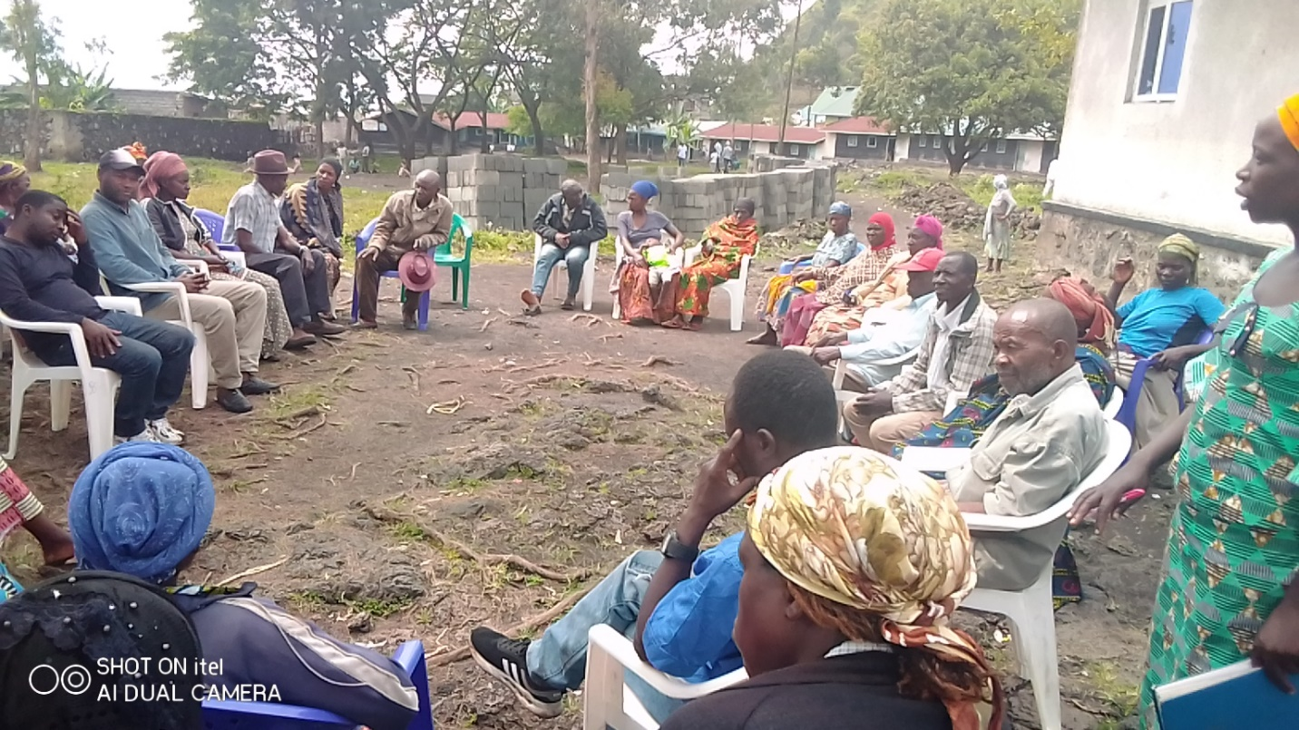
During our Refugee Community Meeting in Goma in December 2022 discussing on various refugee issues.

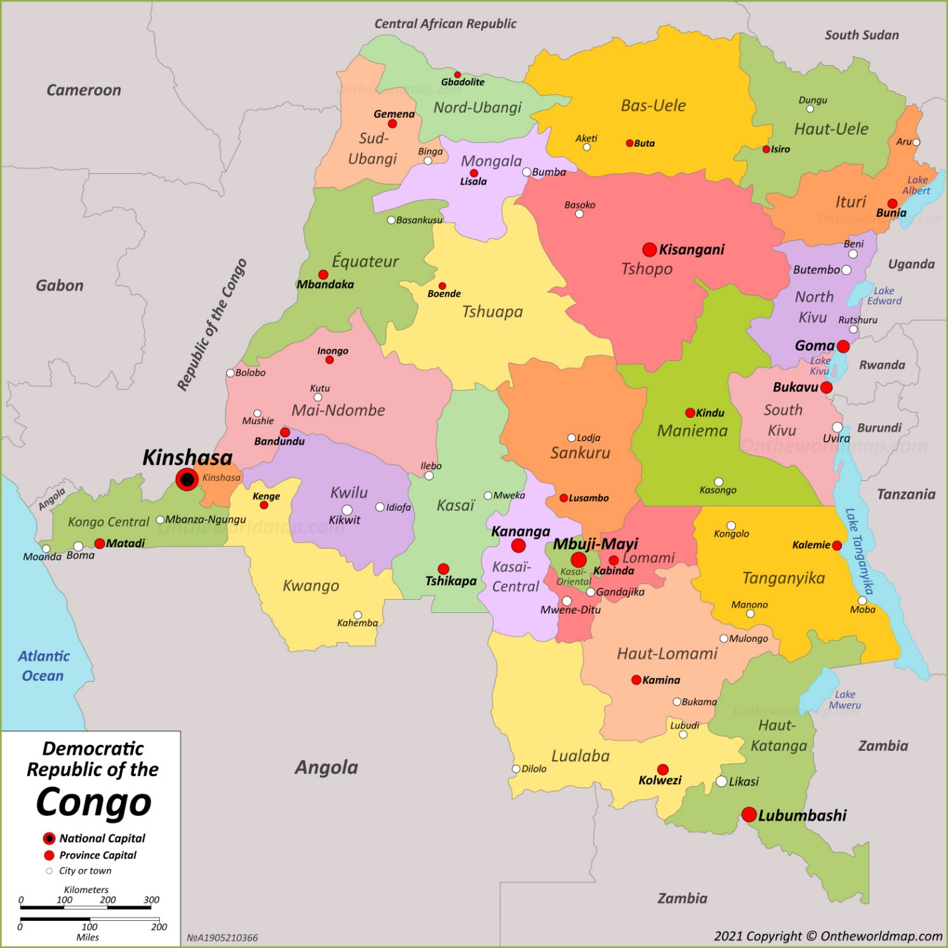
Map of the Democratic Republic of Congo (DRC) with the current 26 provinces in which refugees are found without protection.

COLLECTIF DES ORGANISATIONS DES JEUNES SOLIDAIRES DU CONGO KINSHASA
« COJESKI/RDC »

COORDINATION PROVINCIALE DU NORD-KIVU
Projet : Global Refugee Leaders Forum (GRELEF)

Personnalité Juridique : N°385/CAB/MIN/J & GS/2003 du 30 avril 2003, NGO wi NGO with a Special Consultative Status at the Economic and Social Council of the United Nations (ECOSOC) & Jouissant duStatut d’Observateur auprès de la Commission Africaine des Droits de l’Homme et des Peuples / UA.
NREF: 02/COJESKI/NK/01/2023 Date: 11/01/2023

Annual Report on the situation of refugees in the Democratic Republic in General and in North Kivu for the year 2022 addressed to Development Partners and the UNHCR Nations High Commissioner for Refugees in DRCongo.
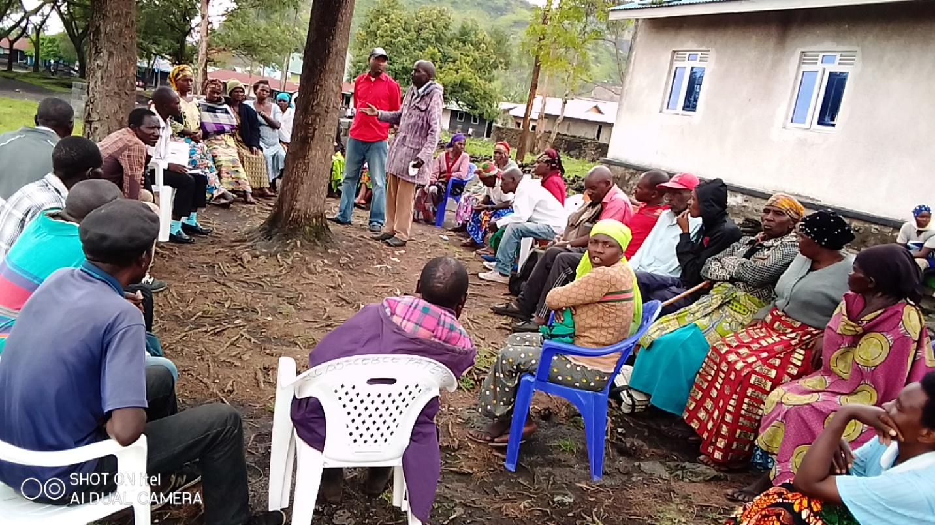
Participants engaging others during our Refugee Information Session in Goma – DRC
Theme: Promoting the Effective Protection of Refugees in the Democratic Republic of Congo
Slogan: “Refugees are not the problem but they have problems”.
Advocacy direction:
Challenging myths, stereotypes and stigma which are used in the criminalization of refugees in DRCongo
Table of content

Profile

Word from the Coordinator of COJESKI/DRC Coordination of North Kivu,

View of the situation by Refugee Progromme Officer

Key Refugee Community Leaders (for security reasons these refugee leaders will not be included in the report).

Background information
About COJESKI DRC…………………………….
About the Report………………………………..
Legal framework…………………………………
Cultural situation………………………………..
Political situation…………………………………
Introduction about the situation of refugees
About refugees in DRCongo…………………………
Humanitarian Actors…………………………………
Host communities……………………………………
DRC Government institutions……………………….
Challenges faced by refugees
Major improvement in 2022……………………………..
Physical security………………………………………..
Freedom of movement…………………………………..
Deportation……………………………………………….
Assassinations…………………………………………..
Forced Repatriation……………………………………..
Arbitrary arrests…………………………………………..
Humanitarian relief aid
Food, Shelter, Education……………………………….
Health care services………………………………….
Income Generating Activities…………………………..
COJESKI main activities in 2022
Advocacy……………………………………..
Community Meetings……………………………..
Refugee Tailoring Project…………………………….
Refugee Charcoal Project…………………………….
Refugee Adult Education Center……………………..
Contact building……………………………………….
Financial Report………………………………………..
Human Resource……………………………………….
Conclusion………………………………………………
Key Recommendations
Introduction of the Refugee Annual Report 2022
Message from the Coordinator of COJESKI/DRC, Coordination of North Kivu,
Once again for the second consecutive time, we are happy to present to you this second annual report focusing on “the effective protection of refugees in the Democratic Republic of Congo”. We humbly thank each one of you who in one way or the other has been on our side in order to understand better how refugees are handled in DRCongo, it is because of you that this work has been made possible.
We also thank the support and collaboration from refugees who continue to believe in our struggle, and lastly we thank all the authorities at various levels in DRCongo who have supported our efforts.
We are much aware that we remain the only ones who have developed interest in the forced migrants affairs in DRCongo, we are much aware that even amongst ourselves many people do not understand this topic and may need trainings, we are aware that refugees themselves do not also know what is protection for them because they have never enjoyed it, we are also aware that various actors especially in the DRCongo Government and the United Nations have implemented over the years a policy that discourages the effective protection of refugees.
By joining this field we therefore deliberately accepted to face resistance and we remained willing to communicate to our audience what we intend to do.
COJESKI/DRC was privileged to have in place staff members who understand very well the whole situation of refugees and that has made our work easy to carry.
We remain engaged towards the promotion of initiatives aiming at the effective protection of refugees in the Democratic Republic of Congo and do commit ourselves that nothing will divert us from such mission. “The protection of refugees in DRC cannot be subjected to either a debate or a compromise, we must do it and it is now the time”.
We humbly request you to read this report and join us during this year 2023 for this cause, which we all collectively lost since 1996.
Yours sincerely
Jean Pascal Mugaruka/ Coordinator
Message from Kulihoshi Musikami Pecos, Refugee Progromme Officer,
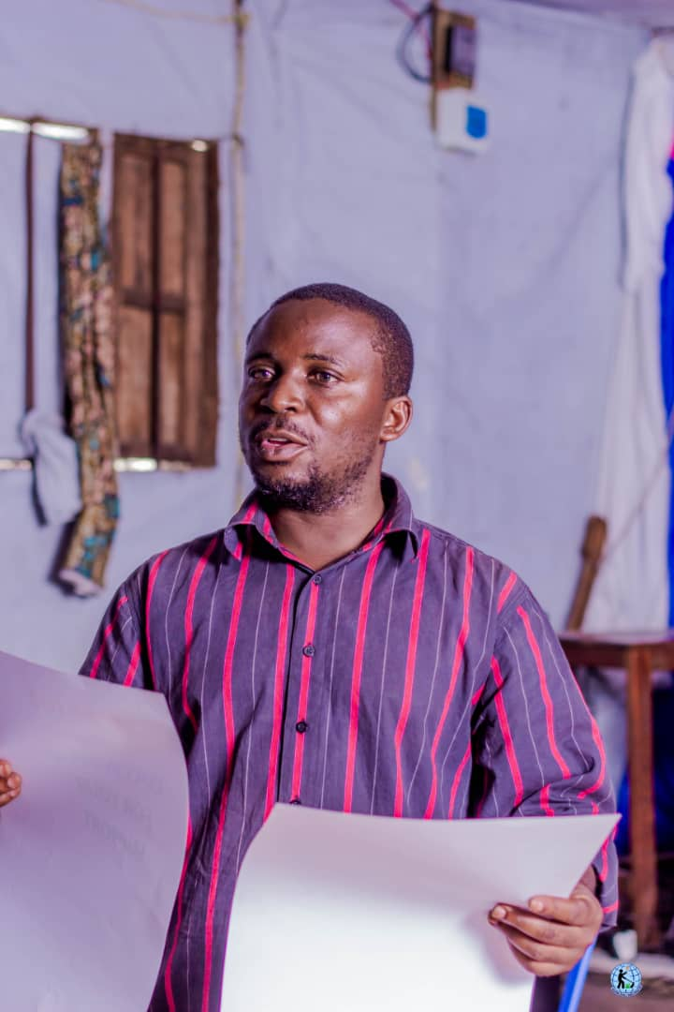
We started the 2022 on a wrong note, just in January 2022 we were bombed by a bad news that UNHCR in Goma will not offer medical treatment to Rwandan Refugees in Goma, this only came to increase the list of those decisions taken mainly in order to harm, in order to discourage people from seeking for protection, in order to put people in a very difficult situation so that they can opt to return back home in Rwanda, a clear sign that refugees in DRC should not count on UNHCR.
The year 2022 started when the highly cherished and the only sexy project of UNHCR in DRCongo strongly funded by the donors was the “ forced repatriation of refugees” mainly back to Rwanda, Burundi and Central African Republic. Yet this practice violated refugee rights as they whole process was not voluntary especially on the side of Rwandan Refugees who were either compelled, manipulated or just given a wrong information.
The year 2022 was not easy for us, because we had then to take difficult decisions to remain alone standing for what we believed in refugee rights, and the cost was high for us. However we survived and did what was possible. Those we believed in would be our allies in order to make our work easy, especially the UNHCR and CNR did not play that role instead they perceived us as a threat to what they were doing against refugees.
Thanks to all those who remained standing with us, especially our staff members and volunteers who had to stand alone sometimes.
“Refugees are not the problem but refugees have problems which we must solve”, and the situation of refugees in DRCongo cannot anymore be left to UNHCR/CNR alone. The protection of refugees cannot be sacrificed at the altar of politics in the Great Lakes Region.
Kulihoshi Musikami Pecos
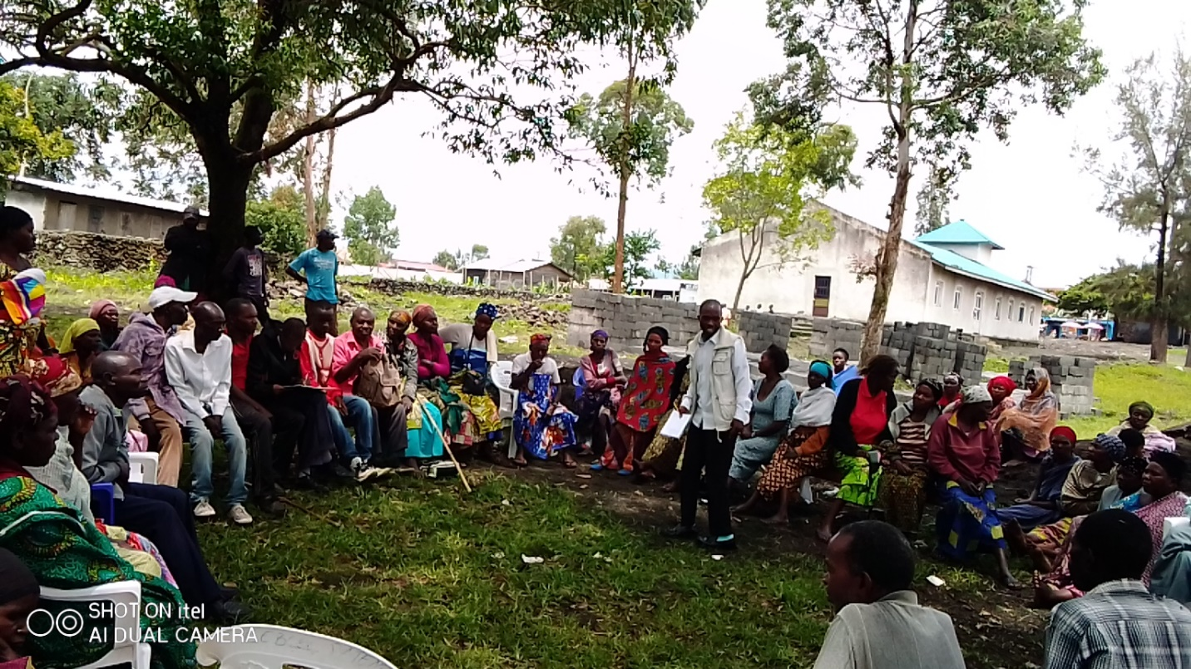
Bringing together stakeholders with refugees, here a community leader from the Civil Society in Goma interacting with refugees in Goma during our community meeting.

About COJESKI/DRC, Coordination of North Kivu
The Collective of Youth Organizations for Solidarity in DRCongo known as COJESKI/DRC is a network of various Youth Initiatives, COJESKI/DRC was created in 1993 and is fully registered by the Government of DRCongo, and COJESKI/DRC focuses on the Promotion of Human Rights, Peace in DRC, Good Governance, Sustainable Development and Humanitarian Actions. COJESKI/DRC has her main offices in Kinshasa, the Capital City of the Democratic Republic of Congo, and also Coordination in all the 11 former provinces of DRC.
The Coordination of COJESKI/DRC in North Kivu Province was then tasked in 2022 to lead the battle for the all humanitarian affairs in DRCongo which include issues of refugees, Internally Displaced Persons and all affected by disaster and other forms of forced migrants in the Democratic Republic of Congo.
Contact COJESKI/DRC, Coordination of North Kivu
Contacts
Our offices are located at the main entrance of Characolina, on the Road to CCLK, after the Catholic University of La Sapientia, Kituku/ Kyeshero, Goma, North Kivu, in the Democratic Republic of Congo.
Tel: +2853191163, email: cojeskinordkivu@gmail.com,
Vision
Empowered young people and actively participate in the community affaires
Mission: To bring young people together in order to make them a strong force that can advocate for change,

Abbreviations
DRC: The Democratic Republic of Congo,
COJESKI: Collective of Youth Organizations for Solidarity,
UNHCR: The United Nations High Commissioner for Refugees,
CNR: The Congolese National Commission for Refugees,
CSos: Civil Society Organizations,
DGM: General Migration Directorate,
ANR: National Agency for Intelligence,
PNC: National Congolese Police,
UN: The United Nations
MONUSCO: The United Nations Mission for the Stability of Congo,
FARDC: Armed Forces of the Democratic Republic of Congo

About this Report
This is our second annual report on the situation of refugees in the Democratic Republic of Congo, it focuses of the different issues that effected refugees in 2022 which include: Abuses against refugees, the progress towards the observance of refugee rights and our activities towards the effective protection of refugees.
This report covers mainly refugees in North Kivu Province but highlights other issues affecting refugees in South Kivu, Province Orientale, Equateur and Kinshasa, where we have networks with refugees.
While the goal is to focus on the entire refugee population in DRCongo, this report will particularly bring out issues affecting Rwandan refugees who are the majority of refugees in North Kivu and who represent more than 80% of the refugee population in DRCongo.
Lastly this report narrates events which we observed and covers some testimonies of refugees from other provinces where we are not yet present.
This report is not therefore an academic research work but rather a compilation of events as they amounted and influenced the lives of refugees which we managed to capture.
The purpose of this report is help our audience to access a wider range of information about the situation of refugees in DRCongo and come up with more ideas that can help in the future. We believe that information provided in this report will bring various opinions, create debates and discussions, challenge what we knew and help people to access what they did not know.
It is rare to read or get information about refugees in the Democratic Republic of Congo, there are few actors involved yet there are millions of refugees who have lived in limbo over the years.
Enjoy and feel free to engage with us.

Confusion on the identity of refugees in DRCongo
During this year 2022 we continued observing that confusion from all actors about who refugees are and even the refugees themselves do not have a clear view of who they are because they have never been informed. This confusion is therefore highly exploited by various actors for various political interests which makes it difficult to ensure that refugees are safe.

As you will read it in this report, some actors have challenges to even refer all these people to the word “ refugees” despite the fact that they came in as refugees and have never lost their refugee status.
For the government of Rwanda, those in DRCongo are not refugees but perceives them either as political actors who want to take over power from Rwanda, either as armed group called FDLR who want to fight against the current regime in Rwanda or as genocidaires who killed thousands of people in Rwanda during the genocide in 1994. For Rwanda all those in DRCongo should be repatriated to Rwanda by force and if not, they should be killed. Rwanda has used this collective criminalization of refugees in order to justify military interventions in eastern DRCongo.
For the United Nations High Commissioner for Refugees (UNHCR), these people are there and no one can clearly tell about their status, what UNHCR knows is that they should be repatriated back to Rwanda as the best way for their protection. UNHCR remain extremely vague on the issue of Rwandan refugees in DRCongo but in action, UNHCR implements the policy which favors Rwanda’s criminalization policy of Rwandan refugees which has existed over the years.
The DRC Government, despite the fact that the current President Felix Tshisekedi has several times publicly acknowledged the presence of Rwandans and the need for DRCongo to ensure their protection, the word “ Rwandan Refugees” has not yet been used clearly and that makes it also vague to really define which Rwandans are we concerned about. The last time when President Felix Tshisekedi used the word refugees was in February 2019.
The Congolese population, do not know who is a refugee, others wonder why people from Rwanda are still refugees, and others cannot make a difference between a refugee and the Internally Displaced person.
It is on this background that this report is being made and in which our work has existed,
Recommendations
We call upon the DRCongo Government and UNHCR to quickly remove this confusion and clearly determine the status of Rwandans refugees who came since 1994 and their children who were born in DRC up to now,
We call upon development partners to support community activities aiming at helping the host communities to understand very well the situation of refugees,
We call upon Rwanda to end the policy of criminalization against Rwandan refugees in DRCongo, and clearly accept that there are genuine reasons why some people are forced to leave Rwanda in order to seek asylum in other countries including DRCongo,
We remind that the protection of refugees is conditioned to our clear understanding of who they are in DRCongo, if that is not done we may risk to lose the battle,
What is the word “refugee” in DRCongo today?
Still in this year 2022 the word refugee did not claim back its meaning as the word “refugee” lost its meaning at the community level in DRCongo and people started using the word “rebels” or “Rwandans” which means all those who are not Congolese and who are doing what is bad to Congolese. In eastern DRCongo the word “Munyarwanda” that means “Rwandan” is associated “to as the worst insult” of those who have done all bad things in the country, and that is how many refugees are perceived. Generally in eastern DRCongo when you talk about refugees, people do directly see “Rwandans” and each refugee from another country is viewed as “Rwandan”. The protection of refugees requires to engage the communities to dissociate bad from people, to make differences between crimes committed by Rwandans from the collective blames, and to look into perspectives how Rwandan refugees faced also abuses as victims.
For many Rwandans, they all know that they are Rwandans but what they do not know is that they are refugees, and for many actually they do not want to be identified as refugees because they fear being deported back to Rwanda. Here is what this one said “I’m from Rwanda but my neighbors know me as Congolese, because I fear to be taken to Rwanda. I wonder why UNHCR here in DRCongo works for Paul Kagame, that is why I don’t want to be identified as a refugee”.
That is a problem which we need to fix, and that needs more efforts in order to come back to the real situation of putting the word refugee into the context, we cannot protect refugees in DRCongo if we do not understand them, if we do not know them and if we are not sure of who they are really.
Recommendations
To make reforms in UNHCR and ensure that UNHCR is more close to refugees and works for all refugees including Rwandan Refugees,
UNHCR should first of abandon the implementation of a pro-Rwandan policy against refugees, and then remove all Rwandan UNHCR staffs,
To put in place activities that aims at assuring people about the change and holding on the effective protection of refugees, especially Rwandans,
Current DRCongo Population
DRCongo is one among the biggest countries in the Great Lakes Region but does not have a clear statistics about her population, it is estimated that DRCongo may have up to 100 million people, with the big number being concentrated in the eastern parts of the country. It makes also the situation more complicated for refugees who also have remained unknown over the years.
According to the United Nations Statistics, the Democratic Republic of Congo has more than 6million of Internally Displaced Persons (IDPs), more than 3million Congolese who are refugees in others countries mainly neighboring countries, but the same UN is not clear even on the estimation about refugees, we believe that there are 4millions refugees inside DRCongo who remain unknown up to now.
Recommendations
We call upon DRC Government to identify all people in the country and issue IDs for each category of persons including refugees,
We call UNHCR/CNR to speedily solve the confusion on the statistics of refugees in DRCongo,
We call upon development partners to make a priority of urgent need to DRC to have in place a data base for her people in generally and for refugees in particular,
Statistics of Refugee population in DRCongo
No one has a clear information about refugees in the Democratic Republic of Congo, not even the United Nations High Commissioner for Refugees (UNHCR) does not have credible data. However the UNHCR statistics indicates that DRCongo has more than 526,000 mainly from Burundi and the Central African Republic which is highly misleading and such data does not merit to appear in public because it gives a false impression about refugees are in the country. UNHCR is not clear about the statistics of Rwandan refugees which is the biggest refugee population in DRCongo.
With the influx of Refugees into DRCongo from Burundi and Rwanda over the years since 1990 up to now, we estimate that DRCongo may host more than “4million” refugees among them more than 70% of the refugee population are living in the east. The following Provinces have a big number of refugees: Kivu, Province Orientale, Equateur, Shaba, Kasai and Kinshasa. Among them the biggest number of refugees are in Kivu mainly in North Kivu, more than 97% of the entire refugee population are Rwandans who largely are still not yet identified.
For example, North Kivu Province could have more than 800,000 refugees among them only 200,000 are registered by UNHCR, and among those already identified only around 2,500 have valid documents, and only around 150 may have access to humanitarian relief aid. We do estimate that Goma could have more than 30,000 refugees among them only around 5,000 are identified by UNHCR and only about 2,500 refugees have valid refugee documents. We believe that more than 80% of the current Rwandan refugee population was born in DRCongo and are less 45 years old.
Our efforts to promote the protection of refugees passes through our deliberate efforts to know them, to identify where they stay, why they stay there, what are their needs and what we can do in order to help them to live better. This passes through sharing the credible information and recognizing that there are refugees who are not yet covered yet they do exist.
In the year 2022 UNHCR claimed that those who are not identified should come and get the necessary documents but this was not the case, refugees reported to CNR offices and were told that the services of refugee IDs do not exist.
We asked UNHCR to harmonize her position with CNR and then communicate the right information to refugees but then that was done, instead UNHCR resorted to silence and could not give any direction about the issue up to now,
Recommendations
UNHCR should put in place services which helps refugees to access the necessary documents especially for refugees from Rwanda,
UNHCR should harmonize with the CNR on a clear communication information about available services to refugees and ensure that refugees easily get documents,
UNHCR should mobilize all actors in order to identify all refugees and put sites which can offer identification services to all refugees especially Rwandans,
UNHCR/CNR should cooperate with CSOs involved in refugee affairs in order to provide necessary information to refugees, and should put in place regularly interaction meetings with CSOs for regular updates on refugee issues,
Refugee Legal Regime in DRCongo
The Democratic Republic of Congo is signatory to the Geneva Convention of 1951, the African Union Convention on Refugees of 1969, and the country domesticated these legal instruments by putting in place a Congolese refugee law of 2002, the Constitution of DRC of 2006 grants refugee rights, but also DRCongo has a vast heritage of culture that favor the protection of refugees and the country being the first African Catholic country may cement all efforts towards forced migrants. And that helps the country to establish the National Commission for Refugees known as “CNR” which works closely in cooperation with the United Nations High Commissioner for Refugees (UNHCR), both are present in various places of the country much as their effectiveness remains a mystery.
Despite this large legal framework the situation of refugees on ground if far different and the determinant about what to do for refugees is not legal rather political. The current leadership in DRCongo has strongly positioned towards the protection of all foreigners in DRCongo but again not much has been said specifically about refugees. This is a positive move on which advocacy can be built towards the specific issues of refugees in the Democratic Republic of Congo in order to challenge the dominance of politics around refugees in the Democratic Republic of Congo.
Recommendations
We call upon various actors to prioritize the awareness of these legal instruments among refugees, the host communities and among leaders at all levels,
We call upon the amendment of the DRCongo Refugee Law in order to make it better in line with other international legal frame and to be able to address the current refugee challenges,
We call upon the DRCongo Government and the development partners to work together on refugee issues and harmonize other government programmes that threatens the desired protection of refugees such as PDDRC-S, and the MONUSCO Programme of DDRR,
We call upon all actors at all levels to abolish the politicization of refugees and criminalize all tendencies at all levels that aims at politicizing the presence of refugees in the Democratic Republic of Congo,
Humanitarian Actors in DRCongo
The Democratic Republic of Congo enjoys the support from various humanitarian agencies and organizations around the world and do operate in various parts of the country, but in most cases they do not focus on refugees, more of their efforts are generally towards IDPs, living aside refugee issues. Goma in North Kivu for example could be described as the capital city of humanitarian relief agencies, but none among them has particular programs focusing on refugees. Even organizations which are worldly known as dealing with refugees, do change their mandate when they come to DRCongo as they do not deal with refugees anymore. UNHCR is largely working on IDPs issues and have less work towards refugees, being the lead for the protection cluster UNHCR does not also have a particular focus on refugees.
In the year 2022 UNHCR only mentioned three (3) times in media the word refugees in DRCongo, the first time it was in relation of refugees in north who are already benefiting from the international protection in July 2022 the second time was in November 2022 on the situation of Rwandan refugees in South Kivu and the third time was in December 2022. We highly regret that once again in 2022 UNHCR kept distance from her roles to ensure the protection of refugees in DRC and as consequence we do not have any humanitarian agency that joined our efforts towards addressing issues affecting refugees.
Recommendations
We call upon UNHCR/CNR to prioritize interventions towards refugees in DRC,
We call upon UNHCR/CNR to strongly engage in effective communication through Social Media, Websites, traditional media on refugee issues,
We call upon UNHCR/CNR to prioritize field work and mobilize more partners and bring on board all actors of the civil society in order to focus on refugee issues,
We call upon the Government of DRC to direct NGOs that deal with refugees globally to focus on their mandate in DRC,
The Congolese Civil Society
Alongside humanitarian relief agencies, there are also various actors from the Congolese Civil Society at all levels but also they do not deal with refugees, they do not know much about refugees and they do not know what to do. The local media, the religious leaders, the community leaders and other stakeholders have little information about refugees and are not even concerned about this situation. What they know is that “those are Rwandans and should go back to their homes”.
To protect refugees in the Democratic Republic of Congo is to help all these actors to access information and put in place inclusive programs that benefits all the members of the communities regardless of their social status. After all the protection of refugees lies in the hands of the members of the host communities and local leaders in their various capacities, once all these actors understand clearly what they need to do then refugees will live better.
In the year 2022 we observed some major progress from the Civil Society Actors who managed to contact us. The Catholic Church now introduced refugees in their prayers of intention every Sunday during Masses in Goma, where the word “refugee” is clearly mentioned,
The local media here in Goma have picked interests in refugee issues when they are called upon, but also the international media has sometimes came,
We also held some interesting meetings with actors of the Civil Society in North Kivu, and some pressure groups,
We remain concerned that all these actors from the civil society did not receive the attention of UNHCR/CNR on contrary some journalist where intimidated and isolated by UNHCR officers during their work to cover refugee stories.
Recommendations
We call upon development partners to fund refugee programs that focus on capacity building of all stakeholders in DRCongo,
We call upon International Media to invest more in refugee programs in DRCongo in order help local journalists who are threatened by UNHCR/CNR staffs,
We call upon UNHCR and CNR to make themselves available for media engagement, stop threats against journalists involved in refugee issues and work toward their protection,
Refugees and the local leaders in DRCongo
Being part of the society, local leaders are so influential and can push for the change of perception, but in most cases they also do not know who refugees are and what they should do in order to help them live in dignity, they have no information about the political position towards refugees.
Still in 2022 most of the violations of refugee rights started from the local leaders who either do not know their roles or have little information about refugees. During our various engagements with local leaders in Goma and outside Goma, they expressed the urgent need to train them in refugee affairs and provide them with necessary contact of persons they can link up with on refugee issues, but also to know what to do for refugees who now identify themselves as Congolese. This local leader from Lake Vert in Goma said “you look at this man you are bringing here, I have known him as a Congolese over the years, and he is registered as Congolese in my book, now today he is saying that he is a refugee from Rwanda. Then if you are a Rwandan refugee you should go back to your country, Rwanda is peaceful, so what are doing here in DRCongo. Look in my book, there are no refugees most of the people in my areas registered as Congolese despite the fact that I know they are Rwandans”.
Recommendations
We need to strengthen strong working relationship with local leaders and put in place regular capacity building programs,
The Government of DRC should instruct local leaders to pay more attention on the situation of refugees, and treat them with dignity,
The local leaders should be encouraged to work closely with refugee opinion leaders, be in contact with UNHCR/CNR and CSOs working with refugees, and be well informed on refugee issues,
Funding should be put in place to train local leaders on refugee issues especially for those who need various services which need money,

Major abuses which affected the physical protection of refugees in the Democratic Republic of Congo in 2022
We were able to monitor the situation of refugees in the whole North Kivu Province, some parts of South Kivu, and kept contacts with refugees in the former Province Orientale, former Equateur, and Kinshasa among others places. The year 2022 was not easy for the protection of refugees because of the war by the M23 backed by Rwanda whose first mission is to deal with refugees, that war alone has increased fear among the refugee population in North Kivu, UNHCR hardly operated because of anti-MONUSCO demonstrations in North Kivu, as we faced that challenge in June 2022 Mr. Kulihoshi Musikami Pecos was arrested and detained for two weeks by the Intelligence Services of ANR and that highly affected our work as refugees feared to be taken to Rwanda and many went into hiding, when asked why he was not coming for our various activities this refugee indicated “ at least you are a Congolese, you did not do anything, but you are arrested in that dangerous place, so what will happen to us who are defenseless?”
And as we conclude this year 2022 two refugee human rights activists Kennedy and Hassani were also arrested and detained by the Police on orders from the head of CNR, we believe that they were arrested because they are critical on refugee issues. Hassani and Kennedy later on were also released on court bail but this affected refugees psychologically and many again are living in fear.
UNHCR Pro-Rwanda Policy
Still in 2022 UNHCR implemented a policy which is closer to Rwanda perception about refugees, mainly based on efforts which were discouraging refugees to seek for protection, reducing the value of the refugee status, deny services and put refugees in difficult situations, and then show them that the best solution was to accept repatriation back to Rwanda where they would live a better life. Refugees who interacted with UNHCR, and CNR officers were even told to consider the option to leave Congo towards Uganda in case they wanted services like resettlement for a third country, and possibility to get food because they will never get those services in DRCongo, these are some of testimonies from refugees. Eric a refugee from Burundi told us “ We went to see the CNR head officer, we were this time six refugees, when he came he found us at the gate, we staring talking but in the process, he told us to consider the option to move towards Uganda because he does not see how we shall get protection here in DRCongo”, on this the UNHCR Sub-Country Representative in Goma also told us one day “ if you feel not safe here, then consider the option to move towards Uganda, there are things we cannot do for you here in DRCongo”.
Changes in UNHCR Goma in North Kivu
Despite the changes of some UNHCR highly controversial officers such the UNHCR Goma Representative, and others in the protection unit, still not much was changed in the way to deal with refugees in terms of offering services. Only UNHCR Goma has been somehow in a low-profile on refugee issues during this year 2022. This was a progress UNHCR changed from being aggressive against refugees to a low-profile strategy to the point the whole year refugees were wondering if UNHCR does still exist. This refugee told us “tell us first of all, does UNHCR exist, do they think about us, and what plan do they have? Again this year will end and UNHCR will not do anything for us, what crimes did we do against UNHCR”.
Impose fear and stigma among refugees
In order to discourage refugees from seeking for the refugee status different strategies were deployed, the first was the war by M23 which was perceived as aiming at killing refugees, this refugee said “We Hutu Rwandan refugees cannot survive M23, if they get us they will just kill us. Paul Kagame gave them a mission to hunt us, our situation is different from that of Congolese, Kagame has killed and massacred us since 1996 up to now but still some few will survive. I do not know what will happen but it may be the last time to meet on this earth, please pray for us”.
The second action strategy was to threaten, arrest and intimidate people who are vocal on refugee issues in order to silence those who give hope and motivate others, this led to the arrest of Kulihoshi Pecos, Hassani and Kennedy, and lastly most of refugees who come to our different activities were intimidated and warned by CNR, UNHCR and AIDES not to come to us and some could not even benefit from some services offered by AIDES.
Strategy of isolation and bribe other refugees
In order to continue pressure on refugees UNHCR, CNR and AIDES opted to offer opportunities to some key refugee leaders who were influential in our activities, in which we lost 3 refugee leaders in benefit of UNHCR, CNR and AIDES among them the refugee women president, the refugee youth leader and another refugee opinion leader who were made “Refugee Community volunteers”. What is evident is that they distanced themselves from us and also denied services, interactions with refugees who come for our activities. One told us “Truly speaking, if these guys from UNHCR, CNR and AIDES gave me this job, it was because you gave me the opportunity to appear as human resource among my fellow refugees, but they also warned me from contact with you and other refugees who come to you, so please do not blame me, understand me because I need this little job”. We also continued receiving information among refugees saying that those who come to us were intimidated and requested by UNHCR, CNR and AIDES officers to stop coming for our various activities. And none among refugees who frequent our activities was invited for events that were organized by UNHCR, CNR and AIDES and this was perceived as a punishment for what they doing with us which the refugee regime perceive as eye-opener for refugees.
This refugee told us “where you sent me, things were not good, they listened to me and after they told me to stop coming to you, saying that we cannot serve two masters, and that if I continue they will never receive anymore”.
Intimidations against journalist
While some journalist picked so much interests in our work on refugee issues, UNHCR/CNR either refused to talk to journalists, either intimidated them not to be close to us and not to publish information about refugees, or just told them they will never be invited in UNHCR activities in case they publish refugee stories which we helped them to collect.
Even if journalists working for international media could not bow their heads to such intimidations because they articles about refugees were needed, local journalists could not broadcast refugee situations which UNHCR was not favorable with and others just could not do anything without asking UNHCR.
But also those who could no longer be invited to UNHCR activities lost some financial opportunities and this demotivated them to venture into refugee issues. This journalist told us “ I feel pity for these refugees, they are suffering so much and we need to help them but look here, let me show you my unfriendly conversation with UNHCR media person, I think she comes from Belgium, she was very clear that she will never involve me in UNHCR field activities if I publish . I need also to survive and these activities also help us to get some money, this is our professional and we must live on that. Me I can no longer get that money, but my colleagues do get it when UNHCR has activities, it affects me” That is why sometimes I cannot initiate stories about refugees anymore, “when you have activities, please invite us and we shall come, there is no problem with that, and if UNHCR does not want to respond we can only broadcast what you gave us, that is fine, and once you invite us, it will not be me to look at by the whole company”.
The refugee leadership in Goma
In 2022 the refugee leadership put in place by UNHCR, CNR, and AIDES confronted us so much, included threats to kidnap us and our relationship deteriorated, until we stopped interactions. We do not know clearly what they reproach us but we were critical in the manner in which they were made refugee representatives and they lack of inclusive services towards all refugees. Apart from some few phone calls to clarify what we are doing and why we are engaged in the protection of refugees, we did not engage so much the current refugee leadership. But also the current refugee leadership did not involve so much refugees who are viewed as coming to us for various activities.
However we worked closely with independent Refugee Community Leaders and still put in place strategies to promote more refugees in leadership roles, so that they can defend others in a situation of problems.
Such actions was portrayed as strategies by Rwanda to silence all those who want to help refugees in DRCongo.
Recommendations
We call upon UNHCR to end all forms of threats and intimidations against vocal refugees,
We call upon UNHCR to distance here self from pro-Rwanda policy and put in place a strategy that favors the protection of refugees,
We call upon UNHCR to work closely with all actors engaged in the protection of refugees and consider as strategic partners rather than looking at us as enemies,
We call upon UNHCR to end all forms of isolation and intimidation against vocal refugees and journalist, and instead encourage and motivate all those who are vocal on refugee issues,

Positive progress in the protection of refugees in 2022
However, despite all the above incidents which we strongly regret, the security of refugees highly improved in 2022. No refugee was deported to Rwanda, no refugee was assassinated, no refugee was arrested by the Police, T2 and Sokola2 and no refugee went missing in Goma and its surroundings.
Cases of arbitrary arrests of refugees in North Kivu
We observed the reduction of arbitrary arrests of refugees in Masisi mainly in Rubaya mining by the Migration Officers, efforts were done and in the process towards July 2022 these arrests stopped, we intervened on behalf of 49 cases. Generally the main reason for the arrest was about expired UNHCR/CNR documents or living in DRCongo without refugee documents because UNHCR/CNR are absent in these areas, and sometimes allegations of being in contact with armed groups especially M23, a fine of about 100$ to 150$ was then imposed to them and those who could not afford it were detained, they were then released after our advocacy. After our interventions most of them were released and up to now this practice seems to have stopped. We engaged local leaders, the Migration Officers, the Security services and refugees themselves. The last case of arbitrary arrest was in July 2022.
Recommendations
We call upon the security services to end completely all kind of arbitrary arrests against refugees, including the pretext of having expired document,
We call upon the security service to end the practice of arresting refugees and asylum seekers who do not have documents on ground that they are illegal migrants and associating them to crimes,
We call upon the refugee regime mainly UNHCR/CNR to engage with the security services in order to share with them clear information on the situation of refugees and best approaches which can be used when refugees and asylum seekers are arrested,
We call upon funding to support refugee programs in the Democratic Republic of Congo, especially various trainings and information sessions to security officers,
Deportation of asylum seekers during military operations in Goma
Again in 2022 there were several security military operations in Goma which targeted undocumented migrants among them asylum seekers mainly from Rwanda. Unfortunately we could not have access to them when they were already arrested, and they were deported shortly generally back to Rwanda. Basing on testimonies from their families left behind in Goma, in most cases only men were deported while the women remained with their children. We do estimate that about 350 undocumented migrants were deported from Goma in 2022 among them a big number are likely to be asylum seekers who could not have access to the information in order to seek asylum.
During security military operations also in Goma, many asylum seekers were arrested as they stayed in DRCongo without documents and many were deported back to Rwanda generally, we estimate that more than 150 asylum seekers were taken back to Rwanda. Our efforts to engage the military to bring these asylum to those in-charge with refugees were futile. This girl from Rwanda whose boyfriend was taken back to Rwanda told us “ please speak for us, defend us, it was our daily prayers seeking for God’s grace to cross into Congo, finally God answered our prayers as we managed to be here, but look again what they have done to my husband, he was arrested and now deported back to Rwanda, I believe he should be in prison now and it may take him about three (3) years in prison, then he will be released and will again work hard in order to save some money which will help him to cross into DRCongo again. Me here my other prayer, if to have a Congolese who can even stay with even if he does not marry me, but just staying with him is enough for my security and protection here. I did not go to UNHCR, I do not know where their offices are, but I also fear they may take me back to Rwanda”.
However on a positive note, in the year 2022 these security military operations reduced in Goma, and suspicions against foreigners also reduces as security threats.
Recommendations
We call upon the military regime to respect the laws of DRCongo and the international conventions during military security operations, the mere fact of not having an identification does not make the person a criminal,
We call upon the military regime to give chance to asylum seekers to express themselves on the reasons why they fled their countries, through an interview in a secured and confidential place,
We call upon the military regime to establish collaboration with all actors involved in the protection of refugees in order to engage with asylum seekers arrested during the security operations in Goma and elsewhere,
We call upon UNHC/CNR to engage with Military Regime in order to make visits and interviews with undocumented migrants before they are deported,
Forced repatriation of refugees back to Rwanda
In this year 2022 UNHCR continued with her forced repatriation of Rwandan refugees in which many were victims of such inhuman operations. We believe that forced repatriations intended to satisfy the appetite of Rwanda that pursues this for various political interests, this had nothing humanitarian. UNHCR argued about the protection and the well-being of refugees but this was a mere cover up, as refugees are much better in DRCongo than in Rwanda. In DRCongo they have freedom and many livelihood opportunities than in their country of origin.
We engaged MONUSCO and Radio Okapi about “ogutahuka Radio Programme” that means “Going back programme” which was used as a propagranda to convince Rwandan refugees to repatriate and in the process the programme was stopped, at least for the last two months now that programme has not been broadcasted. Along this year also 4 Rwandan refugees who were being used to mobilize others to go back and to track all those who were wanted by Rwanda in DRCongo were arrested by the Congolese Security Services and are still detained up to now still refugees were mobilized secretly and sometimes using some influence such as money. We engaged UNHCR through various activities such as Press Conference, open letters, and several communique calling upon UNHCR to end this practice, in our weekly meetings we also informed refugees and tasked them to inform all others, we also collected information on those who were repatriated by they were forced to come back to DRCongo, all these reduced the numbers of those wanting to be repatriated. In December 2022 finally UNHCR publically stated that at least more than 80% of Rwandan refugees who are registered do not want to go back to Rwanda.
And lastly information on our possession indicate that CNR Officers who were involved in convincing refugees to go back also stopped it, and in December 2022 UNHCR recognized for the first time that most of Rwandan refugees do not want to go back to Rwanda.
Recommendations
UNHCR should completely stop all initiatives towards forced repatriation and promote voluntary repatriation of Rwanda refugees that passes through sharing of accurate information to refugees about Rwanda,
UNHCR should distance herself for political influences from Rwanda and strive to work independently on the protection of refugees,
UNHCR should turn the Refugee Repatriation transit center at CCLK Goma into a reception center for new arrivals,
The grant of the refugee status
Despite the fact that some refugees have been waiting for their refugee status over 10 years now, none among was granted the status during the year 2022, information on our possession indicated that only 4 refugees in Goma managed to go through interview. And also along this year we continued to observe the lack of contact between UNHCR/CNR and asylum seekers mainly from Rwanda. Both UNHCR/CNR do not have information policy in place where new arrivals can access information about UNHCR/CNR, and those who have stayed for long do only get negative information about UNHCR/CNR indicating that they will be taken back to Rwanda if they do report to these institutions. It was difficult for asylum seekers to report to UNHCR/CNR as many preferred to come to us for more information and guidance. All Rwandan asylum seekers we referred to CNR in order to be registered were told to go back because the service did not yet exist, they were told to wait as they will be informed.
Recommendations
UNHCR and CNR should have a clear information strategy on how asylum seekers can access their services, especially how to apply for the refugee status and what should happen to asylum seekers who are waiting for the registration,
UNHCR/CNR should work closely with all actors who are in contact with asylum seekers in Goma in order to trace them and offer them possible services,
UNHCR/CNR should have in place a specific team to handle cases of asylum seekers on a daily basis and in order to assure them all and those who have been waiting for long should be granted a refugee status,
UNHCR should put in place urgent humanitarian relief aid to those entering DRCongo especial new arrival asylum seekers,
Credible UNHCR/CNR Staffs
Over the years UNHCR and CNR have employed staffs that are perceived by refugees to be Rwandan, and to make the matter worse these staffs are perceived as being Tutsi working on Hutu refugees. That has affected the image of UNHCR, on the other side some UNHCR/CNR staffs are believed to be living in Rwanda, for refugees these staffs are just intelligence service deployed by Rwanda.
UNHCR/CNR have failed to handle the situation that has been in place over the years in which refugees perceive as working closely with Rwanda, having Rwanda Security Officers as agents of UNHCR/CNR, and as having staffs officers who live in Rwanda.
Recommendations
We call upon UNHCR/CNR to replace all their staffs who are perceived as Rwandans, and to instruct their staff members not to reside in Rwanda and reduce contacts with Rwanda,
We call upon UNHCR to distance herself from Rwanda influence in the field of refugees and clearly request Rwanda to ensure the protection of refugees in DRCongo,
We call upon UNHCR/CNR to work on a new positive image that may assure safety of Rwandan refugees especially Hutus,
UNHCR failure to engage and mobilize other actors
During the demonstrations against the UN Forces in North Kivu, all refugees were completely abandoned by UNHCR. This gave us more time to observe that in actual sense the protection of refugees does not necessary depend on UNHCR but on other factors, and the presence of UNHCR does not influence positively the protection of refugees. While UNHCR offices were closed and all her staffs outside of the country still refugees enjoyed the same protection from the local communities.
We engaged so much the communities through various campaigns to share information about refugees, we engaged various actors of the civil society on the necessity to ensure refugees are safe, and also engaged refugees themselves on what they should do in case of problems,
In the process we did not record physical threats against refugees and the situation was good generally.
Recommendations
UNHCR should unpack her protection power and redefine a clear protection strategy that is community based approach,
UNHCR/CNR should bring on board key actors to strengthen what they are already doing in the field of the protection of refugees,
UNHCR should put in place activities that strengthens refugees in order to respond to their protection needs,
Place of residence: Refugee Camps in DRCongo
Refugees from Burundi, Centre African Republic and South Sudan have camps in DRCongo but Refugees from Rwanda do not have camps, most of them are scatted among host communities in the former 11 provinces and this has been put in place since 1996 up to now. We do not have a clear reason why this is done in this way, but what we observe is that it seems to be more a political move highly imposed by Rwanda and implemented by UNHCR/CNR. We interacted with various local leaders, members of Parliament and kings including the actors of the Civil Society all seemed to wonder why these refugees are not in camps and do not know who took the decision and why such a decision was taken.
Refugees themselves we are in contact with do support the idea of being taken to refugee camps as long as they will not be attacked by Rwanda soldiers anymore, and as long as UNHCR will not hand them over to Rwanda as it was in the past.
Our efforts to advocate for refugee camps in North Kivu were affected by the war launched by M23 and which is still taking place up to now. We strongly believe that refugee camps for all Rwandan refugees in DRCongo will be one among the best solutions to deal with the situations of these refugees who have been left alone over the years. We also Rwandan Refugee Camps in DRCongo are possible and can be fully protected very well by the Congolese Security Services and the UN Forces, and good enough the host communities are willing to give their land for refugees.
Recommendations
We call upon UNHCR to engage the DRCongo Government in order to put in place camps for Rwandan refugees far from the border with Rwanda in line with international standards,
We call upon UNHCR to engage the DRC Government and the UN Forces to ensure security in refugee camps,
We call upon UNHCR to recognize refugee settings which can be considered as centers for all interventions towards the protection of refugees, in line with the UNHCR Policy on refugee alternatives outside the camps,
Food to refugees
In North Kivu refugees were not granted food even those who are already identified by UNHCR were left alone, and there was no clear answer given by UNHCR, this exposed them to more risks especially women and the children. At least 9/10 Rwandan refugee girl or woman has been victim of sexual abuses and the main cause is either the lack of food or the lack of shelter.
Recommendations
We call upon UNHCR to mobilize all her partners in order to provide food to all refugees in DRCongo especially to Rwandan refugees,
We call upon UNHCR to engage the United Nations and all other development partners on the urgent to support refugees especially Rwandans in DRCongo with food,
We call upon UNHCR to engage all other humanitarian agencies and organizations to consider the urgent need to offer relief aid to refugees in DRCongo,
Medical assistance
At the beginning of this year 2022 UNHCR terminated partnership with Medical Centers in Goma which offered basic medical treatment to Rwandan Refugees especially that these centers were located near places of residence of so many refugees, and these centers could also extend medical treatment to those who are not yet identified by UNHCR. Such decision was viewed as highly political and it did not intend to protect Rwandan Refugees but to force them to go back as UNHCR created bad conditions which could force refugees to opt to go back indirectly or to pretend to exist. In 2022 UNHCR signed partnership with other medical centers in town which were not accessible to so many Rwandan Refugees who do not know much about Goma town, fear to go to town and the centers were just far. The few who accessed these health centers indicated that they could not have the medicine, as the Doctors only prescribed them the medicine and told them to go and buy from the Pharmacies yet refugees did not have money. One among these Health Centers was called Raphael which was supported by the European Union.
In 2022 we identified 13 Rwandan Refugees in Goma and around Goma who died due to the lack of medical treatment, and yet their lives could have been saved. They all resorted to harbor medicine, others believed it was witchcraft and others resorted to prayers. UNHCR needs to take good decisions that takes into account the interests of refugees that will only happen when UNHCR stops to be influence by Rwanda.
Recommendations
UNHCR should ensure that each refugee gets access to health services through partnership with health centers located where refugees live,
UNHCR should put to the end the so called “Mutuelle de Sante” and instead promote universal health services to all refugees through partnership with health centers directly,
UNHCR should end the practice to condition refugee document as a requirement in order to access health services and encourage all those who do not have yet document to access health services,
Freedom of movement
We observed improvement in the freedom of movement of refugees in North Kivu by using their refugee identification especially for those who now have refugee identification cards. Refugees moved within North Kivu and in South Kivu, and no one was arrested. However many were blocked for a while and exposed to interrogation about that Refugee Cards mainly by the security services from the Congolese Army and the Migration Directorate. However it was difficult for all those who do not have Refugee ID Cards to move outside Goma. Cases of arrests were mainly at Mubambiro near Sake town where there is roadblock.
Recommendations
We call upon UNHCR/CNR to issue identification Cards to all refugees in DRCongo especially to Rwandan refugees,
We call upon UNHCR and Development partners to allocate funding on programs that aims at creating awareness about refugees and the documents used by refugees in DRCongo,
We call upon UNHCR and CNR to work closely with all security services in order to share information on the situation of refugees,
Refugee Travel Document
As it is mentioned in the current laws governing refugees in DRCongo, refugees should acquire Travel Documents which can allow them to visit other countries. In 2022 refugee leaders in North Kivu had two opportunities, one in Uganda and the other in South Africa, they applied for the Travel Document but they did not receive any feedback up to now, instead somewhere intimidated by CNR officers for applying for that document.
Recommendations
CNR and UNHCR should do all what they can to ensure refugees who wish to go outside may access the Travel Document,
UNHCR and CNR should put in place a clear information on how refugees should apply for the travel document and how long it may take in order to get it,
UNHCR should provide the necessary funding which will cover the cost of the travel documents to refugees who wish to go outside,
Education
A small number of Rwandan refugee children continued to benefit from UNHCR school fees in 2022, education to refugee children in Goma and around Goma is one among UNHCR Programs which is badly implemented. The school fees is only limited to those in primary schools, not all the children in the family were paid for, the school fee did not cover the whole yean but generally UNHCR paid for some months. Some children received money for three (3) months, others for 6 months and others nothing at all, the money for the children was cut off and no answer was given, some children did not get the money despite the fact that were on the list. So many problems and no one could answer, we observed the same strategy of the trio “ UNHCR, AIDES, and the Bank” when a refugee goes to claim to A, he will be sent to B, and B will sent him to C, and C will send him to A, until he gets tired and abandons the claim.
Recommendations
We call upon UNHCR to officially partners with some schools which offer education to refugee children,
We call upon UNHCR to put in place an information session on refugees about scholarship for refugees,
We call upon UNHCR to harmonize the working relationship with the Bank, and ensure that all refugees are considered for the school fees,
Scholarship for higher education
In 2022 some DAFI Scholarships were made available to refugees in Goma, and were told to apply but in the process they were not selected, still the only available information was a notice on the gates of UNHCR/CNR where many refugees do not frequent in order to access the information. Refugees have already a negative attitude towards UNHCR/CNR and AIDES which come together in order to decide, but also many refugees believe that these actors already have their own refugees they select for available opportunities, and they are the ones who are known. This was the other challenge, and UNHCR/CNR have not yet addressed this communication gaps, despite the fact they have various opportunities to do so.
Recommendations
We call upon UNHCR/CNR to put in place a transparent process which can ensure that the selection is done on basis of merit,
We call upon UNHCR/CNR to shift the priority of those who benefit from the scholarship and bring in other new people who are not connected to UNHCR and CNR officers,
We call upon UNHCR/CNR to ensure that the selection is done by independent people, and encourage all refugees interested to apply,
We call upon UNHCR/CNR to ensure that Rwandan Refugee also benefit from the scholarship and popularize the information among refugee communities,
Major of challenge of documents faced by refugees in 2022
The challenges of the refugee documents was highly connected to all the refugee problems and was the cause to many refugee right violations such as arbitrary arrests, lack of freedom of movement, access to humanitarian relief aid, problems in the areas of residence with local communities, exclusions and all forms of discriminations, tensions with the local communities over the Congolese Voter’s Cards among others.
Some refugees have old UNHCR/CNR Attestations which expired in December 2021 for some others in 2018, others in 2015 and others in 2013 which have not yet been renewed up to now, some do not have them, others changed residences and others missed the September 2021 UNHCR Verification in Goma and the same time UNHCR did not continue with the verification process in other places in North Kivu, children do not have birth certificate, refugees cannot access marriage certificates.
UNHCR should work hard to solve the issue of documents of refugees in DRCongo as this represent more than 85% of the causes of the refugee problems currently. In 2022 UNHCR could not give any explanation why it could not grant documents to all these refugees. The document is essential as it is at the center of refugee protection and refugees cannot access support if they are not identified.
In the absence of the Refugee Identification Card, some refugees have resorted at acquiring the Congolese Voter’s Card which is also at the center of tension between refugees and host communities. This also is misinterpreted among different actors and puts refugees at high risks of violence with local communities, it should be quickly fixed.
Lack of the visibility of UNHCR/CNR
Refugees and asylum seekers have little information about UNHCR/CNR, and again in 2022 UNHCR/CNR did not do much to come closer to refugees, only some few Community Volunteers were introduced in Goma but this did not solve the issue, as these volunteers seemed not in position to advocate for the cases in order to be solved. UNHCR has maintained a highly secrete presence, and no single public meeting was organized with refugees. Most of activities in which UNHCR/CNR are visible were against the interests of refugees, refugees can easily argue about how UNHCR/CNR are harmful rather than how they are protected,
Alongside the few Community Volunteers, we also have refugee Welfare community which is highly contested and in the year 2022 they did not even hold a single refugee meeting. The Refugee welfare community put in place by UNHCR/CNR does not get involve so much of issues affecting Rwandan refugees who represent more than 90% of the registered refugees in Goma and its surroundings.
Lack of the refugee agenda by development partners
Despite the fact that development partners had refugees as priority in their engagement with various governments in Africa, in DRCongo no embassy issued a statement about refugees, no Embassy visited refugees in DRCongo, no Embassy put in place a programme or project focusing on refugees, no Embassy publically published funding for refugee programs, no Embassy interacted or organized a meeting with the Civil Society on refugee issues, only the High Commissioner of Canada invited us for cocktail in December 2022.
The absence of development partners in issues affecting refugees has also blocked the revival for the protection of refugees in DRCongo, and this should at least change during this year 2023.
Hunger and famine
In North Kivu most of Rwandan Refugees live near Virunga National Parc and survive on the contact with the Parc either by the cutting of trees for charcoal or to get involved in agriculture. Unfortunately in year 2022 Virunga National Parc was highly invaded by M23 and this pushed many refugees away exposed to hunger and other consequences, those around Goma cannot access the Parc up to now and have challenges to survive. Many refugees in Goma and around Goma have serious problems to get food as both Virunga National Parc and Rutshuru are not accessible because of the M23 war.
Despite all call for actions still UNHCR, the Government and Development actors only fixed their eyes towards Internally Displace Persons and nothing at all was either said or initiated towards refugees. This pushed some refugees to leave their homes and moved towards IDPs Camps around Goma where they also stayed and registered as IDPs in order to get food assistance.
Fear of M23
Refugees believe that M23 was created and started the war in order to kill them and the few who will remain will be taken to Rwanda where they fear being persecuted. All Rwandan refugees are following up what is happening between the Congolese Army and the M23, however the current tensions between Rwanda and DRCongo is highly appreciated by refugees who believe that it favors their security because Rwandan security services will not penetrate inside DRC to hunt them.
With the M23 refugees were divided into 3 groups and that dictated what they should and how they would respond to the threats of M23.
The first group of refugees despite the fact of being Hutus, were recruited for military activities by M23 mainly in order to be safe and for their families to remain safe in Goma. This woman said “look here, we do not have yet the refugee card, and if M23 come to Goma we shall all die, so my husband decided to join M23 so that we can be safe when they enter Goma, rather than fleeing again to places where we do not know, we also hope he will get a good job when they enter Goma”.
We have received testimonies of Rwandan refugees who were recruited by M23 and these refugees are right now among the fighters, however this is the cause of the problem with those who did not join as they asked us in a community meeting “now some among us joined M23, what shall we do when this war is over and they come back to the communities, are we likely to be safe”.
Another category of refugees joined the FDLR which was resisting against M23 in Virunga National Parc, some do come back to visit their family members and this seems to be accepted among the communities, this one said to us “ we have no option apart from fighting now, there is nothing we can do, M23 is looking for us, they believe that we are all FDLR, their target is to destroy us and disperse us, so we must join others in the forest, fight to our best in order to ensure that all refugee areas in Goma, Masisi and Nyiragongo are safe”.
The last category of refugees are just there waiting to see what will happen ready to run away in case of war by M23 in Goma, resting to prayers but also wondering where should they go in case of the war. What is certain in that in this situation many Rwandan refugees believe that the one thing that will protect is their ability to camouflage as Congolese.
Conflict with the local communities
There are regular conflicts with the local communities mostly connected to the ownership of land, issues of trust among people over an agreement, marriage and cohabitation among partners and issues to do with money. The very biggest problem is the issue of so many refugees pretending to be Congolese, participate in national politics and camouflage as Congolese in order to integrate the public administration. Rwandan refugees we deal with are fully aware of that but claim they have no other option as per now because this helps them to survive Rwanda security influence in the areas and also to access basic necessary services. While actors of the Civil Society are advocating to ensure that these refugees are removed and send back to Rwanda.
Refugee Access to justice
Crimes committed against refugees at national level seem not being put into consideration, and at the local levels justice to refugees is still a big challenge, as many are considered as “Rwandans” who have no right to justice.
In this situation refugees are always victims and do loose the case before they even appear at the local authority or at the Police because they are told to be Rwandans and do not have something to ask from a Congolese. The other challenge is also the money involved in order to listen to cases at all levels, at the community levels each person has to pay at least 20$ per case and this is also general to all people, at the Police it is more than 50$, refugees are always not in position to pay this money just because they do not get it. While the CNR tried to follow-up some cases this could not cover all and the most forgotten were those who do not have yet refugee documents.
Conflicts among refugees themselves
Beyond the security issues where refugees seem to be divided into various groups among political and security forces in North Kivu, we also observed that there are so many conflicts among refugees themselves which are connected to mistrust, problems between women and their husbands, and the issue to either to return back to Rwanda or to remain in DRCongo among others. Above the biggest problem among refugees especially those from Rwanda is the suspicion among themselves to be either connected to Rwanda or to be radical opposed against Rwanda. The refugee settings and places of residence is dictated by the perception of position, those who believe they can easily move to Rwanda and come back to DRC are in their places, those who believe they cannot go to Rwanda are also in their places and those who are totally opposed to Rwanda are also in their places.

COJESKI/DRC INTERVENTIONS TOWARDS REFUGEES IN 2022
We moved forward with our promotion of the effective protection of Refugees in the Democratic Republic of Congo. We believe that the protection of refugees will end the pretext from Rwanda to attack RDCongo, will highly reduce armed groups who recruit from refugee population and will end tension over land with local Congolese population. The protection of refugees is for us an issue of security, humanitarian and of the peace in the great lakes region and cannot be compromised or even discussed, it must be there.
In order to advance this notion we focused firstly on communication through social media, the press and Media and networking. Our first approach is “to mitigate stereotypes, challenge myths surrounding Rwandan refugees, confront stigma and provide accurate information to our audience”.
Our approach is to focus on what people do not know about refugees, on what actors have never said about refugees in order to challenge the culture of criminalization of refugees in DRCongo which they suffered since 1996 up to now.
We believe that in 2022 a section of Congolese and people outside DRCongo fully knew about refugees in DRC and the way we can deal with them in dignity and peace.
Social Media on refugee issues in DRCongo
We maintained two WhatsApp Groups where issues connected to refugees are discussed, one is for refugees’ alones in DRCongo and the second is for Stakeholders on refugee issues in DRCongo. The first one has 76 refugee members from DRCongo especially living in North Kivu, South Kivu, Kisangani, Bunia, Mbandaka, Kalemie and Kinshasa, the second one has stakeholders from the whole DRCongo such as local leaders, government officials, UN Officials, leaders of political parties, Members of the Parliament, Civil Society Actors and the Congolese from the Diaspora among others.
We also circulate regularly various messages on social media mainly WhatsAp in 28 Groups and send messages to 1356 numbers which are on WhatsApp. Generally in 2022 we believe that more than 25,000 people mainly in DRCongo received our messages on the situation of refugees and more than 100,000 people received our messages indirectly. Our advocacy messages focuses on right information about refugees, on the violations of refugee rights, on the obligations of Congolese to protect refugees, on mitigation of negative propaganda against refugees, on political exploitation of refugees and how refugees can to help improve the situation in DRCongo. We also communicate using Facebook, Twitter and LinkedIn among others through individual accounts. Our website also currently has become a place where people do get information from about refugees and generally each post does reach to more than 300 people it has reached, and also the website is regularly updated.
The major challenges in this social media campaign is necessary to collect information, many refugees do not have access to a smart-phone and funding.
Emails
Our mailing list is about 1500 emails who regularly get our updates on the situation of refugees especially of helping our audience to access the right information about refugees in DRCongo, our struggle last year 2022 was to provide people with accurate information and mitigate lies that have been built around refugees in DRCongo, but also help others to get their first information about refugees in DRCongo.
The major challenges also is to collect the necessary information and the human resource to handle this communication strategy which needs more volunteers to come on board,
Website:
We have in place website which does receive regular updates on refugee issues,
Media engagement: Press Conference
In 2022 we organized three (3) press conferences bringing together 23 Journalists from 14 Media Companies both local, national and international. The Press conferences focused on the situation of refugees especially on what the public did not know about refugees in DRCongo.
Media Investigations and field visits
Basing on our various social media posts two media mainly the Voice of America and TV Monde picked interested and broadcasted stories of investigations in the fields about the situation of refugees in North Kivu focusing on issues which were not broadcasted over the years.
Reactions for negative information against refugees
We made 6 reactions either to media, to a statement from stakeholders of to the local population which we considered as negative against refugees, this again was done through media or through social media, sometimes we also organized physical contacts with the parties concerned and discussed on the true picture about refugees.
Interviews with the Press
We managed to make 11 interviews which were broadcasted in various media houses both local and national focusing on issues affecting refugees in the Democratic Republic of Congo.
Radio Talk show
We were invited and participated in 5 Radio Talk show and one TV interview on various refugee issues in Goma, DRC, these were only limited to local media based in Goma and attracted the audience of many who were clarified on what they knew wrongly about refugees.
Online media
In 2022 a total number of 9 online media published our articles and held interviews with us on the situation of refugees in DRCongo, and these articles reached to so many people. One Journalist told us that our reaction on his online article on the situation of refugees was the very first article which received the highest number of viewers in 2022.
Meetings
We attended 7 meetings organized by various Pro-Democracy Pressure Groups in Goma, and two meetings organized by the Civil Society, one Conference in Goma focusing on the security where we addressed issues around refugees and three online Zoom meetings where we presented refugee issues in DRCongo,
We also managed to meet 6 authorities and held phone calls with 2 authorities mainly in the Army and in the Intelligence Services on the refugee issues, and lastly in December 2022 we were invited for a cocktail organized by the Embassy of Canada in Kinshasa.
Letters on refugee matters in DRCongo
In 2022 we addressed four open letters to various authorities about the situation of refugees at local and national levels, in responses some authorities called us for a meeting and exchanged information on the situation. We got two responses from the authorities who also deployed their staffs to follow- up with us on issues raised.
Visitors who came to our offices
We received 7 visitors from other institutions wanting to know more about refugees in the Democratic Republic of Congo, among them two came outside and five where internal, as one was from the United Nations Agencies working with UN Women.
Advocacy at the local leader’s levels
We interacted with 10 local leaders in Rutshuru, Masisi, Nyirango and Goma North Kivu, who had issues with refugees and we had to intervene and explain to them challenges faced by refugees. As per now some local leaders do now give us reports about refugees in their areas, before this did not exist.
Following up cases
We handled two refugee cases at the Military Courts in Goma, 27 cases at the local authorities and 8 cases at the Police, we also visited 6 refugees at the Police, 4 in Military Custody and 10 refugees in Munzenze main prison in Goma. We made 3 visits in Munzenze main Prison in Goma, and also two visits in Military custody in Goma. As per now more than 27 refugees are detained in various prisons for different crimes but they are not identified as refugees, they are either known as foreigners or as Congolese, and one known as Muzaire died recently in December 2022 few days after being released from Munzenze main prison in Goma. We believe that refugees and asylum seekers should not be in prison especially that they committed crimes which were connected to their status of vulnerability. At least more than 75% of refugees detained in Munzenze main prison are accused of interactions with Virunga National Parc.
Arbitrary arrests
Three events characterized arbitrary arrests of refugees in North Kivu, lack of documents of expired documents especially in Masisi Territory where we intervened and helped more than 250 refugees to be released, some were arrested in groups others individually. Military operations around Goma where undocumented migrants and those without valid refugee documents were arrested, in total we intervened and more than 73 were released, and then those with fake documents, whereby we secured the release of 3 refugees in Goma.
While the security military operations were reduced in Goma towards the second semester of 2022 which also ended arbitrary arrests of refugees, the very last cases of arrest of refugees in Massisi was also in August 2022, up to now the situation is relatively calm.
Mediation and conflict resolution
We handled 31 cases of conflicts between refugees among themselves and between refugees and the host communities, but also conflicts between refugees and their local leaders. The problems between refugees and local leaders are generally connected to the issue of refugee identity or lack of the identity.
We also handled 17 cases of refugees with their landlords because they failed to pay house rent, the mediation was considered as the best option.
Refugee Community Meetings
In the year 2022 we held two refugee community meetings every week in Goma, one in Byahi which is held every Thursday at 9am and the second at CCLK which is held every Friday at 10 am also. We estimate that more than 6,500 refugees participated directly in these meetings.
Recording of refugees without documents
We continued the recording of refugees who have no documents or whose documents have expired and as per now we have so far registered more than 12,000 people. Each person is issued a paper that shows that he/she is known to us and in case of problems that helps us to track the person and conduct possible interventions. In 2022 confusion about this paper reduced and various actors did not discriminate refugees who have the paper which we offered them. However challenges are still so many and needs more attention.
Referrals of refugees
Most of our referrals were generally based on those with medical needs, and those with document issues that can be solve by CNR and UNHCR and those who need attention from the local authorities. A total number of 19 cases were referred to CNR and UNHCR, and 32 cases to local authorities in refugee areas of resident.
Welcoming new arrivals
We received 48 new arrivals along the year 2022 some did not have where to stay while others were received by their fellow refugees, among them 2 came from Burundi and the rest came from Rwanda, but also two refugees who were registered in Uganda and who decided to leave and come to DRCongo. The main raison they indicated for their feeing was related to persecutions they faced in their countries of origin. We interacted with them and connected them to others who can facilitate them to live here in Goma.
Repatriation of Congolese in Uganda
We received 11 Congolese from Uganda and voluntary and who came to seek services at our offices as they did not know where to stay for a while and if there are services here in Goma for them when they come back. Because we do not have yet potential partner in this we only interacted with them and encouraged them to look for support from local churches around Goma.
Information for voluntary repatriation
Despite the fact that refugees are not willing to go back to Rwanda, still some came to our offices to seek for information on how they can go back to Rwanda. We interacted with 61 people on issues of going back to Rwanda, among them we were informed that only 2 families decided to return to Rwanda. Among issues discussed was the lack of clear information on the whole return process which we believe we provided to those wanting to go back. We observed that the major interest to seek for repatriation was the money given to those who wish to go back once they are in Rwanda.
Repatriated to Rwanda and come back to DRCongo
Much as we have not yet worked so much on this issue, still 4 refugees visited our offices and indicated that they came back from Rwanda, they were repatriated but once in Rwanda they decided to leave again, and their desire was on how they can still get the refugee status.
Rwandan refugees wanting to move to Uganda
At least 20 refugees interacted with us on issues of the refugees in Uganda and how they can cross up to Uganda. We provided them with clear information and among them so far we were told that two left DRCongo and are now in Uganda. The main reason was generally alleged comments from UNHCR/CNR officers who encourage or advise Rwandan refugees to move to Uganda where they will get better services especially relief aid, livelihood opportunities, resettlement for a third country, and refugee documents.
We provided them with clear information about the refugee situation in Uganda and mitigated wrong and exaggerated information they were told about the better life condition of refugees in Uganda.
Refugees leaving camps in Uganda to DRCongo
We received 3 cases of Rwandan refugees who left KyakaII and Kyangwali Camps in Uganda and came to stay in DRCongo. At the office they wanted mostly to find out if they can get humanitarian relief aid and how they can seek for the refugee status in DRCongo.
Once again this information was not yet available on how to deal with such cases and up to now there is no clear information.
Interactions with stakeholders
One leader from a political party exchanged with refugees and 5 local leaders attended our community meetings where they were informed directly about the situation of refugees. We also had phone calls with 2 Members of the Parliament on issues of refugees, and then two phone calls with top Military Officers.
Cooperation with stakeholders
While the cooperation between us and the other stakeholders is excellent as most of the stakeholders we are in contact with wish do not understand more the issues surrounding refugees and what they can do in order to help, our relationship with UNHCR/CNR has not been good. In 2022 we requested for a meeting with UNHCR/CNR but in vain, refugees who were referred to UNHCR/CNR were received but also claimed to have been intimidated and warned not to associate with us, and some among those who attend our different activities do tell us that they are being discriminated by UNHCR/CNR because of coming for our various activities. However sometimes we managed to communicate through social media on issues about cases of some refugees. UNHCR/CNR seem to have developed their own perceptions against us yet we are not a threat, we just want to support all that is in place to ensure the effective protection of refugees.

COJESKI/DRC Projects for Refugees in North Kivu
The Refugee Women Craft Project
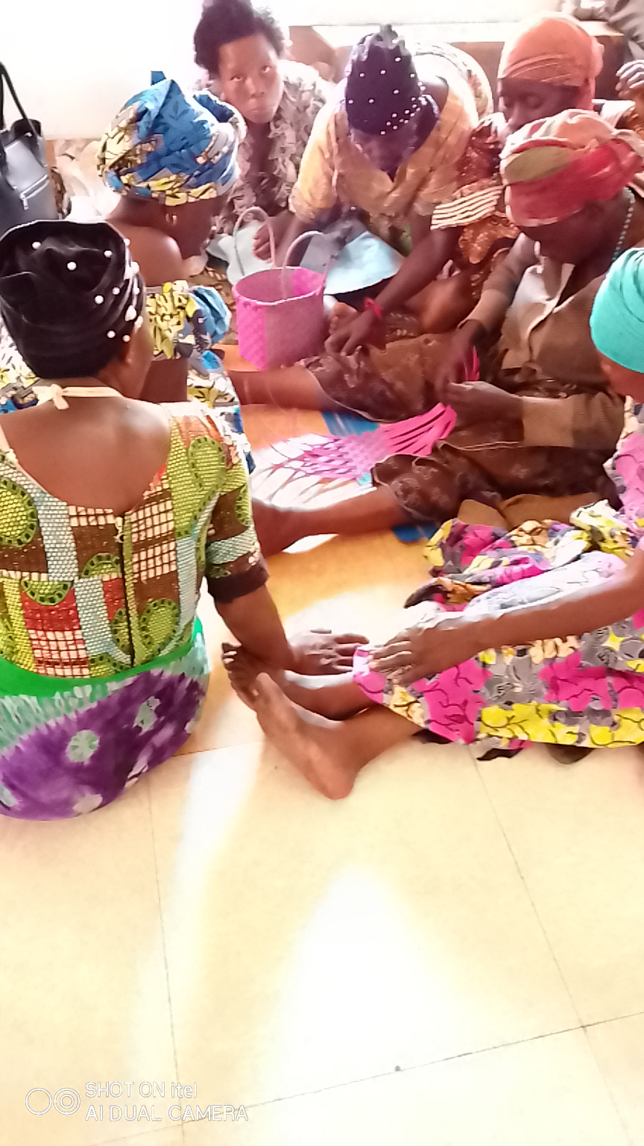
Refugee women during their craft learning activity at our offices in Goma - DRC,
This project brings together refugees women and they continued with their activities during the year 2022, despite the challenges connected mainly to finance. They do meet once per week and make their activities and then sell what they have managed to make, generally they often meet on Wednesday from 9am – 1pm and on Friday shortly after our Community Meeting, as per 2022 33 refugee women are involved in this project.
Refugee Tailoring Center
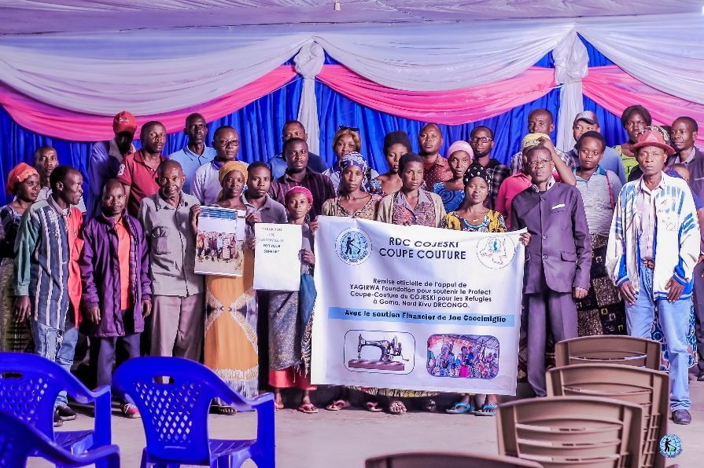
This was in December 2022 during the official launch of the Refugee Tailoring Center in Goma, DRC
This year 2022 was not easy as it had so many challenges but still 10 refugee women completed their training in tailoring. Among then six benefited a shewing machine from a Project by AJVDC, supported by EDC and funded by the USAID. In the year 2022 the Refugee Tailoring Project received some support from Yagirwa Foundation belonging to the Congolese in Diaspora based in the United States of America, and this facilitated the training of 13 refugees in Tailoring.
Refugee Charcoal Project
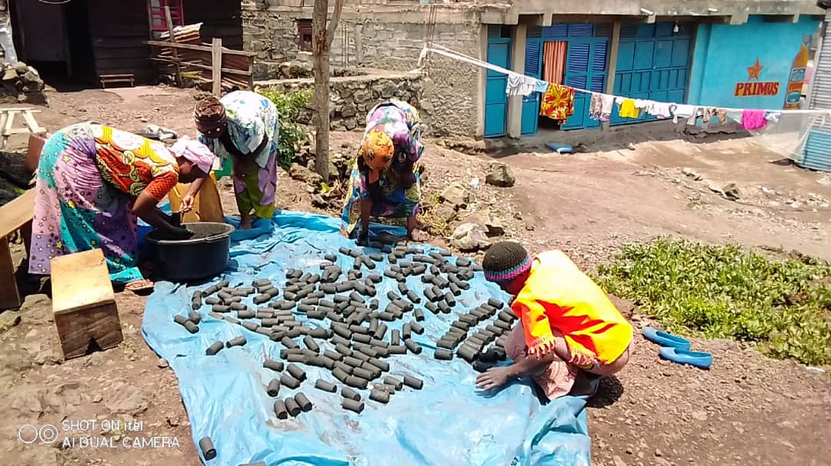
Refugees making their innovative Charcoal in Goma which is too economical for many families including the host communities.
This activity seems to be one among the most important ones which is progressing on well. A total of 13 refugees are involved in making Charcoal every Thursday and Saturday in the morning, the charcoal is therefore sold, currently with the numbers of IDPs around Goma the demand for the charcoal is high but also people are getting used to it and seems of high quality. In the year 2022 the Charcoal project received also some support from partners based in Uganda and in Israel working for “Aniye Movement”.
Refugee Adult Literacy
At total of 11 adult leaders attended classes twice a week until June 2022 when the programme was stopped because the teacher got another job and we could afford to hire another one up to now.
Refugee Saving Group
Two refugee saving groups were formed among them one is still active while the other had challenges with the leadership that misused the money already saved. The one active has 20 members, and also refugees organized themselves to save money for the end of the year party which again they distributed among themselves because of the current security situation they did not to be involved in a party.
Agriculture
With opportunities that came along the way, we managed to get land which was given to us by some people of good will, for refugees to cultivate in order to get food, so far 28 refugees were involved in agriculture in Goma and Nyiragongo. We thank so much the partnership with some Catholic Nuns in Goma who gave their land to refugees and employed some in their planation in order to get some money, we also thank AJVDC which has given us the land at CCLK.
Social interventions
We intervened on the situation of two refugees who gave birth and could not manage to pay the hospital bills, we paid rent for 3 refugees, and we paid medical bills for 16 refugees, and granted food to 3 vulnerable elderly refugee women, but participated and contributed financially for the burial of 5 refugees. We helped 4 refugees arrested by the police with some money in order to eat and pay the prison fee, and also brought food twice to refugees in Munzenze main prison, at the same we assisted with food to 5 refugee women whose husbands are detained.
Partnership contact building
We continued our strong partnership with AJVDC and together we provided opportunities to refugees who benefited from the shewing machines, and also where involved in trainings local communities how to make charcoal.
A Catholic Nun based in Goma, came to us and provided land to refugees where they planted different things and also hired some refugees in her plantation which gave them some money for their daily needs,
We established collaboration with some pressure groups in Goma and that helped them to understand clearly the situation of refugees, we also remained in touch with the Civil Society, we exchanged with the Common Wealth Secretariat on the issues of refugees in DRCongo, especially why Rwandans are running from Rwanda and why those in DRCongo do not want to go back, we also interacted with the Canadian High Commission in Kinshasa, OXFORD Forced Migrants Center, UKAID, and many other organizations.
Threats and security challenges
In the year 2022 we received various forms of threats and intimidations generally coming from UNHCR/CNR and their associates hired from Security Services, and phone calls from Rwanda Security Services. The main cause was only our desire to promote the protection of refugees which did not attract the attention of other players in the refugee affairs. As consequence this led to the arrest and arbitrary detention of Kulihoshi Musikami Pecos by the Congolese Intelligence Services (ANR) for two weeks in Goma, he was then released through interventions from various human rights defenders and the MONUSCO Human Rights Department.
Shortly intimidations were also addressed towards refugee leaders who are vocal on various refugee issues which led to the arrest of Muco Kennedy and Nimbona Hassani in order to silence them, they were also released on court bail two weeks after their detention.
FINANCIAL REPORT FOR THE YEAR 2022
The year 2022 ended without funding, as most of our activities were run by contributions from volunteers and member organizations and partners, each one individually in activities he/she is involved in, this was a challenge to record money spent by each person in order to do the work. But these key activities consumed money from our volunteers generally.
The office rent was paid by our partner AJVDC for the whole year,
The necessary equipment we use mainly laptops, internet, printing, photocopying and other basic needs were covered individually by volunteers as well as the field work was also covered by each volunteer.
Contributions from member organizations helped also to run other activities which are taking place.
Last year 2022 we managed to get donations from two well-wishers, one donated some money for the Charcoal Project and another one donated some money for the Tailoring project.
Human Resource
The year 2022 we were also able to have inadequate human resource, we had in place 7 volunteers who worked for a period of at least six (6) months in place facing the challenges both in number and in effectiveness in terms of capacity. However we worked with a highly motivated human resource that passed through numerous challenges but still they managed to do their best for the advantage of refugees. On top of that our efforts also motivated refugees and engaged them to play various roles in their communities as part of the community leaders.
Conclusion
Until the end of the year 2022 we remained perplexed and with questions which are not yet answered if UNHCR/CNR are really engaged towards the protection of refugees and if UNHCR/CNR have a plan for that, on ground we saw very little which can give us a glimpse of UNHCR/CNR willingness to ensure that refugees are safe regardless of who they are and where they are.
However again most of UNHCR/CNR actions tended at discouraging refugees even to seek for protection, therefore milting their hope in UNHCR/CNR and giving a picture that they are not there for the cause of refugees.
More than 85% of the refugee abuses in 2022 in DRCongo are connected to the lack of documentation and the ignorance of various stakeholders about refugees, still UNHCR/CNR did not do much to mitigate those two challenges. On contrary threats and intimidations mounted on us we believe that these challenges can be effectively addressed.
Nothing much can be done together if we do not yet have assurance from UNHCR/CNR about their commitments to ensure the effective protection of each refugee, for us the issue of the protection of refugees in DRCongo cannot be subjected to a debate, it is a must and each party must make clear his/her position.
More advocacy actions will be considered for the year 2023 and beyond to ensure that our desire to have the protection of refugees in DRCongo is fulfilled.

Key recommendations for the year 2022
Basing on the above described in this report we therefore formulate these recommendations which we believe if taken seriously by each actor mainly UNHCR/CNR and the Development Partners, can dramatically change the situation of refugees in within the next four months in the Democratic Republic of Congo,
Development partners in DRCongo
To include refugees and internally displaced persons as one among their Strategic Diplomatic Agenda in the Democratic Republic of Congo,
To put in place a specific urgent and very flexible funding opportunities for refugee initiatives, grassroots civil society organizations and for organizations working on refugee issues in DRCongo,
To including refugees in all protects being implemented in DRCongo that are funded by Development partners,
To include refugees on the agenda for all interactions and exchange with all stakeholders at all levels local, national, regional and international,
To exchange with refugees during their various field works and field visits in the Democratic Republic of Congo,
To publish regularly their programmes and activities towards refugees in DRCongo in their various social media and websites,
To engage UNHCR to prioritize the documentation to all refugees in the Democratic Republic of Congo,
To engage the DRC Government to make necessary positive change in the National Commission for Refugees (CNR),
To promote and give resettlement opportunities to refugees in DRCongo and urgent protection opportunities to human rights defenders working on the refugee issues in DRCongo,
UNHCR/CNR in DRCongo
To put in place a clear policy that aims at effective protection of each refugee in the Democratic Republic of Congo,
To urgently embark of granting refugee status and issuing Refugee Identification Card to each refugee in DRCongo especially to those who are in areas that are safe, and solve all problems which are connected to refugee documents,
To operate changes and transfer of staffs who are viewed as being Rwandan or residing in Rwanda, terminate contracts of staffs who operated in various rebels and armed groups since 1996,
To aggressively publicize activities towards the protection of refugees in social media, highly involve the Press and Media at all levels local, national, regional and international,
To engage partners and stakeholders at all levels local, national, regional and international on issues affecting refugees in DRCongo,
To strengthen, motivate and empower all actors that are doing all they can to promote the effective protection of refugees among them human rights defenders and journalists, and strongly condemn threats and intimidations towards all actors working on refugee rights in DRCongo,
To stop all controversial activities which are highly suspected by refugees as being dictated by their countries of origin such as the forced repatriation and discourage initiatives towards repatriation of refugees which violates international standards,
To condition the strict observance of refugee rights with support to CNR and other implementing organizations, and seek for accountability from partners about their engagement to promote refugee rights in line with international requirements,
To involve refugees in decision making and empower them to face the challenges with resilience,
To ensure that UNHCR/CNR interventions are inclusive, accessible to all refugees and urgently ban selective programmes which benefit to only a section of refugees. But also to put in mind that interventions should focus of equity alongside equality.
To promote all the durable solutions to refugees in DRCongo mainly: Local Integration, Voluntary Repatriation and Resettlement for a third country,
To engage the DRCongo government in order make the necessary reforms of the National Commission for Refugees,
To capitalize and strengthen the already existing refugee protection opportunities at all levels: Community, National, Regional and International,
To engage and encourage the DRCongo National Commission for Refugees to effectively participate in all forums of engagement around refugee issue at local, national, regional and international level,
Thanks.
COJESKI/DRC, PROVINCIAL COORDINATION OF NORTH KIVU, GOMA DRC.

