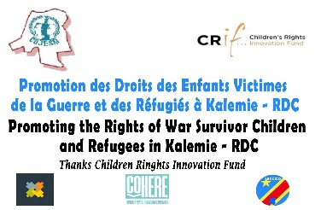
One among our visibility Material during the implementation of the project.
Final Report of the end of the Project to Children’s Rights Innovation Fund focusing on youth rights in Kalemie City, Tanganyika Province, DRC.
Introduction
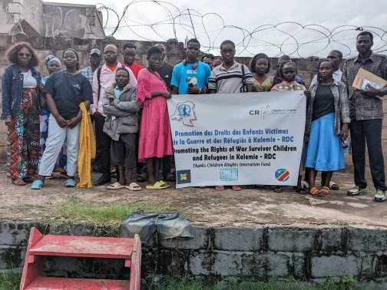
A group photo with the very first 20 young people selected to attend the trainings. This is the same group which putting in place various Savings and Associations.
The Collective of Youth Organizations for Solidarity in the Democratic Republic of Congo, Coordination of Goma, received a grant of 13,000 USA from Children’s Rights Innovation Fund (CRIF) in order to advance the rights of young people and make their voices heard. The funds were initially proposed to be implemented in Goma City, North Kivu Province and would engage young people in strong activism.
However shortly Goma and a larger part of North Kivu was captured by the AFC/M23 rebels backed by Rwanda in January 2025, this affected our initial plans and we had to adapt to the situation. The project was supposed to empower and raise up the voices of young people in Internally Displaced Camps, Refugees and young people engaged in different pressure groups movements in Goma among the marginalized communities.
Actions taken
We did a security assessment and realized that our staff members and our offices were targeted by the armed forces in Goma, and this led to the closure of our offices in Goma until the situation comes back to normal. We also observed that both North Kivu, South Kivu and Ituri Provinces have been affected by different wars for the last 30 years, and our assumption that war will end with the access to power of the current President in DRC was not accurate. However we realized that Maniema, Tshopo and Tanganiya Province which are neighboring the Kivu and Ituri have been generally calm. In order to push the organization for a long-term plan we realized that we should be stable and that is why we decided to relocate the main office in Kalemie Tanganyika Province and then National Offices in Kinshasa the Capital City.
The massive movement of Internally Displaced Persons from North Kivu and South Kivu towards Kalemie and the high presence of refugees from Burundi and Rwanda in Tanganyika Province motivated our choice to set up our office there in order to implement and offer services to South Kivu, North Kivu, Maniema and Ituri Province. We also looked at the accessibility as Tanganyika Province has a connected with Tanzania, it has an Airport, and a road up to Lubumbashi among other opportunities.
Difference between Kalemie and Goma
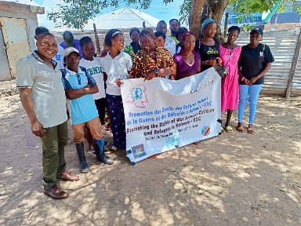
This is our very first initiative to bring people together and empower them, this was during their meeting at our offices in Kalemie.
In Goma where the project was supposed to be implemented people were already mobilized and organized in various groups, and young people were so much active in holding public demonstrations and other activities in order to demand for the end of the war. In Kalemie that did not exist, it was difficult even to find an Association or a group of young people, IDP were not yet organized as they had just arrived and their first priorities were basic needs: Food, shelter, Medical Treatment among others.
Refugees have lived in Kalemie in extreme poverty and vulnerability and lacked ideas on how they can organize themselves, and lastly people in Kalemie City have been in IDP Camps for long and remained too much vulnerable.
Positive things about Tanganyika Province
It became a province in 2015 when DRC passed from 11 Provinces to the current 2026 Provinces, half of the province is covered by a forest, it has a fertile soil, it is rich in natural minerals, and has two main ethnic groups mainly the Pygmies and Baluba (Bantu). These two ethnic groups have been fighting against each other and more efforts are still needed in order to restore total peace and coexistence among the two groups. Pygmies are the most vulnerable as they live in extreme poverty. The Province has big potential of fishing and other activities such as agriculture but which remain not fully exploited.
Even if DRC has no clear statistics of the population, Tanganyika Province has an estimated number 3million people which makes it less occupied, while this small number of people are a challenge in order to develop the province, it is also an opportunity to skill a strong human resource.
Challenges
While the province is too big, but has only 3million people and the rest of parts are not yet occupied, this is caused by the lack of basic services such adequate health care, access to clean water in order to avoid Cholera which claims many lives almost every year, better living conditions and the basic infrastructure such as roads, electricity, public transport, among others. Over the years the province was supported by humanitarian relief organizations which based their approach on direct handout through food items, this has left people with mentality to rely on relief aid rather than to empower them through development approach especially agriculture and other livelihood activities.
People do not have the culture of civic engagement and issues such as human rights, good governance, leadership, democracy are totally new to many and this is why the population is not demanding better services from the leaders.
Civil Society Organizations and Youth Initiatives
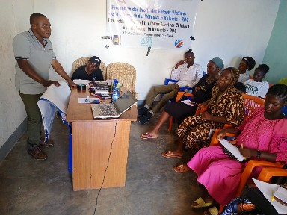
Capacity building of young people at our office in Kalemie about human rights, good governance, creating associations and economic activities.
Kalemie City has a very weak and fragmented Civil Society organizations but they are also very few and not so much inclusive, generally most of civil society organizations are backed by political actors and serve more the political agenda, and in this way the province lacks independent civil society organizations. Over the years, the youth did not know that they need to organize themselves and participate in community solutions, it was in 2025 that Tanganyika Province put in place the very first Provincial Youth Council. Tanganyika has no printed media, it has one independent Radio FM, and some few other radios sponsored by political actors. However people have access to social especially those in Kalemie who have the network but the content of discussions in social media remains a challenge.
OUR APPROACH DURING THE PROJECT
During the implementation of this project we had to change the approach because of the above mentioned, we first of all started with building relationship with young people in different places, we also conducted a survey to identify those who are in position of leadership in Kalemie City such as in churches, schools among others. Then, we organized trainings in order to empower them and lastly we are following them up as they create different groups and associations.
Village Savings and Credit Associations (VSCA)
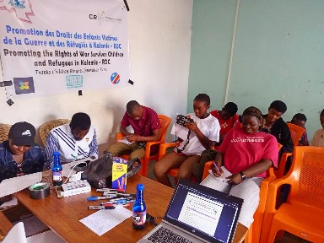
Here participants are being briefed on how to create and manage the group, this was done in our offices in Kalemie.
We introduced this idea among young people which is about bringing them together and contribute some money each week in order to fund their ideas and help them to have sustainable Income Generating Activity and other livelihood activities. As per now, we have 13 VSCA in Kalemie City bring together 25 young people in each VSCA who always meet once a week and who are generally from the marginalized communities such refugees, Internally Displaced Persons, young people from poor communities, and those who are too vulnerable.
Civic Engagement
With the presence of these very first groups where it is easy to find young people, we have also engaged on human rights awareness, and other issues about capacity building and helping them to play a positive role in proving solutions to problems in their communities. It is through these groups that young people are becoming aware about their rights, about the need to demand for better services and to learn about advocacy and activism.
Financial support to VSCA
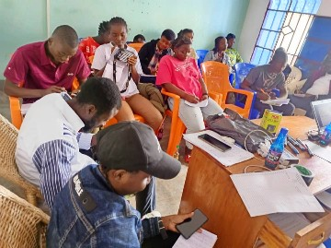
During our interactive meeting on how best we can support the groups.
Due to the funding, we have only been able to support 5 VSCA financially in order to appear more organized and be able to serve well their members. However this was not our original idea, we want to replicate what we initiated in Goma. We put 25 young people in a VSCA, four among them take the position of leadership, we grant each person 100$ to start or to boost an Income Generating Activity, then they agree how much they will save each week, the money they agree is divided into two parts: The first part is kept by the treasurer of VSCA and this supports others who may not have starting capital, and may also be used to add for those who want more money, the second part is kept by COJESKI-DRC at our offices and aims at supporting those who are doing well in the group, it is also used as loan and helps them to organize social events. The VSCA also agrees on a small amount of money they will contribute each week in order to solve social issues among members such as events like marriage, death, medical treatment among others. This idea was not implemented because of the funding but it is one among the best ideas for long-term.
Results
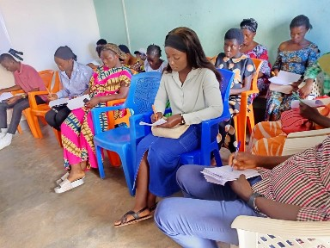
Deliberately more than 60% of participants in this project are women and young girls who are our main focus also.
50 young people holding leadership roles were trained in human rights, youth leadership and making associations and groups among young people in order to play a positive role in the communities. As per now we have three (3) youth associations which have been created by those who attended the trainings, now the challenge is to help them to register with the government.
20 young people were trained in human rights, leadership and how to start a Village Saving and Credit Association and how to progress economically, as per now 13 VSCA have been created by those who attended the trainings and each having at least 25 members. These VSCA are offering leadership opportunities for the very first time 52 people in Kalemie now,
Five (5) VSCA have been financially supported in order to improve their living conditions,
We have conducted seven (7) human rights awareness sessions amongst members of these VSCA,
Recommendations
We call upon Children’s Rights Innovation Fund to consider supporting us with more funds in order to progress in what we have already started in Tanganyika Province by putting in place the foundation for youth engagement. The funding should focus on capacity building, starting capital for Income Generating Activities and for social events and campaigns,
We call upon Children’s Rights Innovation Fund to consider the need to include marginalized people such as Pygmies who require a special attention and approach in order to minimize conflicts and exclusion,
We call upon Children’s Rights Innovation Fund to consider funding for a year or even two years in order to bring in place the change we want to seek of young people fully engaged in affairs of their well-being at all levels,
SUMMERY OF THE BUDGET ALLOCATION
Movement of the Bank Signatories from Beni North Kivu to Kampala Uganda then to Lubumbashi and from Bujumbura to Lubumbashi which include documents, Visas, accommodation and other basic needs: 2,000$
Medical treatment to one of the Bank Signatory who fell sick in Lubumbashi: 1,000$,
Office rent in Kalemie and some few office furniture: 2,000
Visits in different communities in Kalemie in order to be closer to young people: 500$,
Survey to identify young people for our various trainings: 500$
Four (days) training of 20 young people in Small Income Generating Activities in Kalemie City: 1,500$,
One (1) Training of 50 young people holding leadership roles in Kalemie City: 1,500$
Financial support to five (5) VSCA in Kalemie: 1,000$
Staff Allowances: 1,000$
Transport, accommodation and allowances to the Trainer from Goma North Kivu to Kalemie: 1,000$
Total: 13,000$
Done in Kinshasa, June 20th, 2026

